Graduation Project II
2024-2025

Optimization of Small Molecule-induced Early Cardiac Differentiation from Human Embryonic Stem Cells

Name: XIUYI WU
Student ID: CC112579
Department: Faculty of Health sciences, UM
Time: 4 May, 2025

Abstract
Efficient generation of cardiomyocyte subtypes from human embryonic stem cells (hESCs) is essential for modeling cardiac development and advancing regenerative therapies. In this study, we developed a robust, chemically defined differentiation protocol that leverages sequential modulation of WNT and BMP signaling to guide early cardiogenic commitment. Activation of WNT signaling via CHIR99021 followed by BMP4 induction and LDN-193189 inhibition effectively directed hESCs toward SHF-biased mesoderm with diminished FHF marker expression (e.g., TBX5). Building upon this dual-lineage foundation, the subsequent application of retinoic acid (RA) further refined chamber-specific fate, promoting atrial and ventricular subtype specification. Dose-dependent analysis revealed that low concentrations of RA (0.1–0.5 μM) facilitated selective expression of atrial or ventricular markers, whereas higher doses impaired cardiomyocyte differentiation and induced non-myocyte-like morphology. Molecular and morphological characterization through qRT-PCR, flow cytometry analysis, and immunofluorescence confirmed enhanced chamber-specific gene expression and improved sarcomeric organization compared with passaged non-additional treated cardiomycyte. Importantly, the integration of RA into the BMP-based protocol improved differentiation consistency and subtype fidelity. This study offers a reproducible and scalable small-molecule-driven approach for cardiomyocyte subtype specification, with significant potential for cardiac disease modeling and high-throughput drug screening.
Keywords: human embryonic stem cells, cardiomyocyte differentiation, WNT, BMP, retinoic acid, small-molecule induction, chamber-specific specification

1. Introduction
Cardiac progenitor cells are increasingly recognized as a promising source for regenerative therapies due to their ability to differentiate into functional cardiomyocytes. Human embryonic stem cells (hESCs) offer a valuable platform for generating these progenitors; however, existing differentiation protocols often rely on serum-containing media and exogenous growth factors, leading to variability and limited reproducibility [3-5].​ Moreover, serum- and protein-based methods are costly, pose infection risks, and are unsuitable for large-scale or clinical applications. To address these challenges, serum-free, chemically defined media have been developed to provide a more controlled environment for studying cardiac differentiation mechanisms [8, 9].

Existing models, as shown in Figure 1, suggest that both first heart field (FHF) and the second heart field (SHF) progenitors arise from a common cardiomesodermal source marked by PDGFRA, KDR, and MESP1, and are subsequently committed under ISL1 expression. While WNT(Wingless/Integrated), BMP (Bone morphogenetic protein), and retinoic acid (RA) are known to guide this process, we observed that single-factor stimulation—such as BMP or WNT activation alone—failed to consistently separate FHF and SHF populations. This highlights the insufficiency of isolated signals in recapitulating the complexity of in vivo lineage segregation.

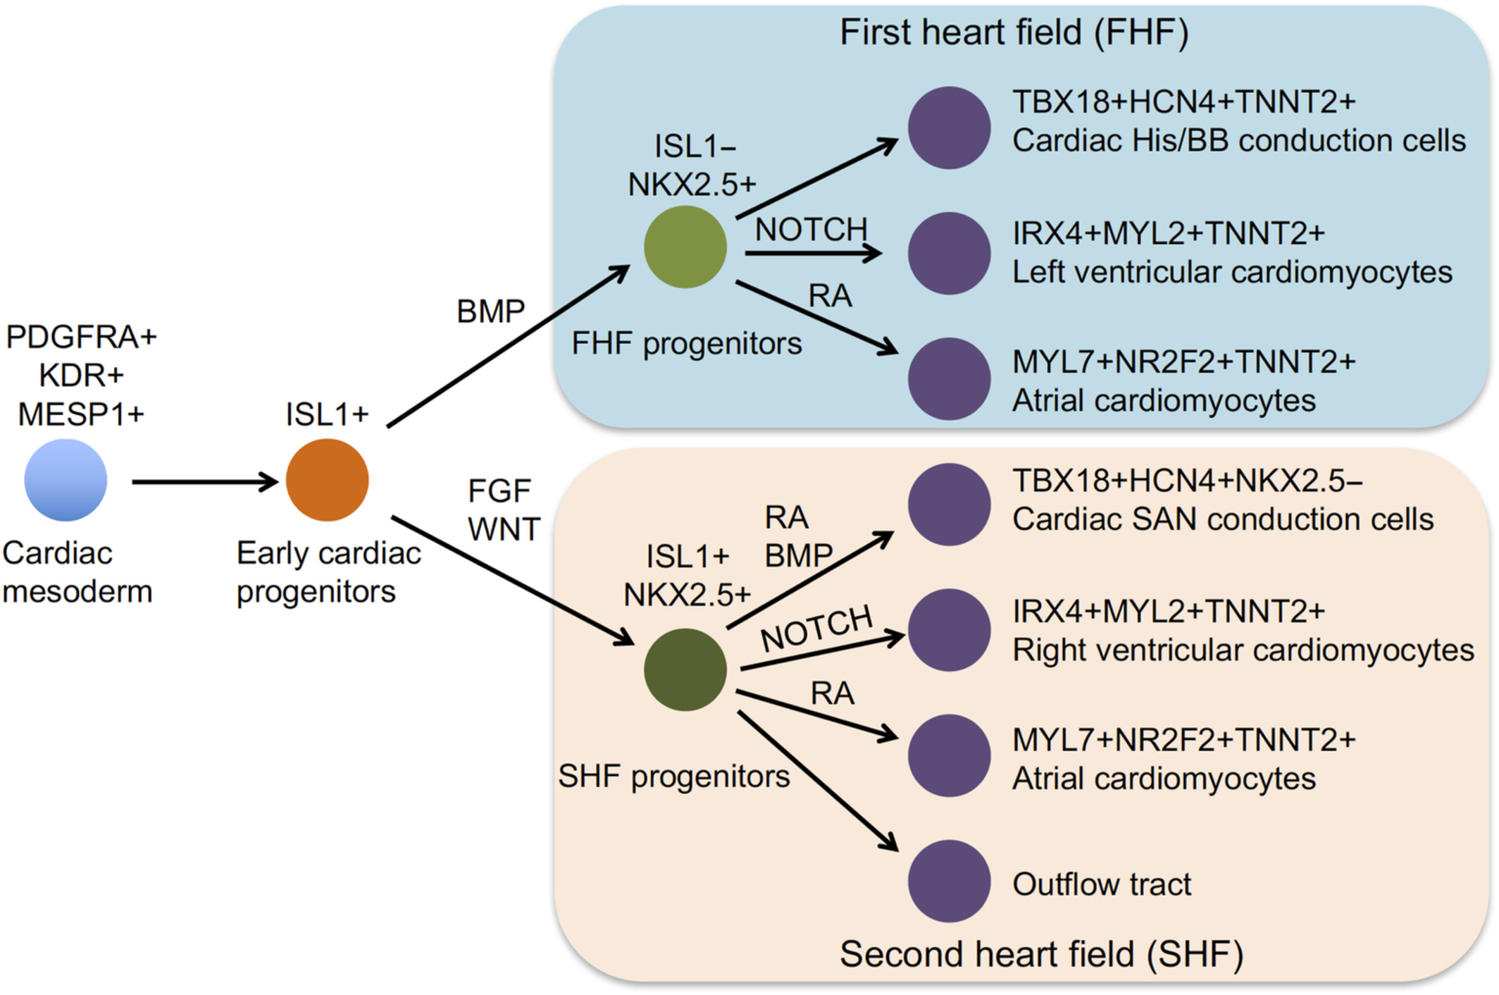
This study focuses on clarifying the regulatory effects of small-molecule strategies in directing the transition from early cardiac progenitors to FHF and SHF identities. Special emphasis is placed on the dose- and time-dependent effects of RA input in two-dimensional cardiac differentiation cultures.
Figure 1
A schematic representation of cardiomyocyte lineage specification during early cardiac development [1].
Cardiac mesoderm arises in response to WNT and BMP4 signals post-gastrulation and is characterized by the expression of early mesodermal markers such as MESP1, KDR, and PDGFRA. These cardiac mesoderm cells give rise to ISL1⁺ cardiovascular progenitors, which subsequently diverge into two major lineages: the first heart field (FHF) and the second heart field (SHF). FHF progenitors (ISL1⁻/NKX2.5⁺) predominantly contribute to the left ventricle and part of the atria, while SHF progenitors (ISL1⁺/NKX2.5⁺) give rise to the right ventricle, outflow tract, and additional atrial cells. This lineage divergence is orchestrated by both extrinsic signaling inputs—including BMP, RA, and NOTCH pathways—and intrinsic transcriptional regulators such as GATA4, MEF2C, NKX2.5, and TBX5. Additional progenitor pools, such as HCN4⁺ cells, may also contribute to pacemaker populations such as the sinoatrial node (SAN).
Adapted from Zhao et al. (2020), Stem Cells, 38(7), 822–833. https://doi.org/10.1002/stem.3178

In this study, a classical two-stage protocol is employed. During the first stage, mesoderm induction is achieved either by WNT activation (WNT ON) alone or by combined activation of WNT and BMP signaling. In the second stage, differentiation proceeds either under basal conditions or with the addition of BMP inhibition, followed in both cases by WNT inhibition (WNT OFF) to further promote cardiac fate commitment. This process, combined with a small-molecule-guided modulation of WNT, BMP, and RA signaling pathways, enabled efficient generation of cardiomyocyte subtypes with defined atrial and ventricular identities from hESCs (Figure 2) [10-12]. To better understand how progenitor identity influences downstream cardiomyocyte fate, we analyzed the differential expression of ISL1 and TBX5 across cardiac progenitor subpopulations. Our lab's unpublished data suggest that FHF progenitors exhibit low ISL1 but high TBX5 levels, while SHF progenitors are characterized by elevated expression of both ISL1 and TBX5. These early transcriptional differences are maintained and reflected in their respective cardiomyocyte derivatives—particularly in left versus right ventricular subtypes—and serve as a predictive marker for lineage trajectory. This approach improves differentiation efficiency and reproducibility, facilitating applications in disease modeling and regenerative medicine.
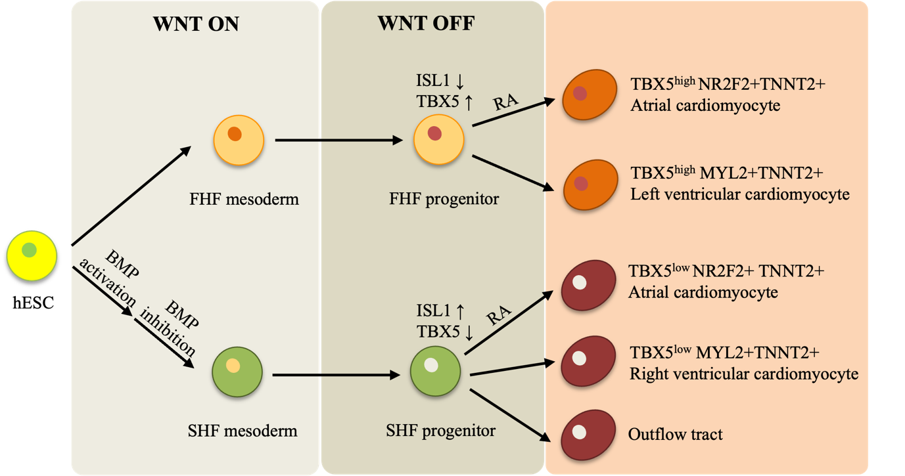
Figure 2
Schematic illustration of cardiomyocyte subtype specification from hESCs through stepwise modulation of WNT, BMP, and RA signaling.
In the early mesodermal stage (WNT ON), sequential BMP activation followed by BMP inhibition guides lineage commitment toward the second heart field (SHF) mesoderm, whereas in the absence of this modulation, cells tend to adopt a first heart field (FHF) fate. Upon WNT inhibition (WNT OFF), distinct progenitor populations emerge, with FHF progenitors expressing low ISL1 and high TBX5 levels, and SHF progenitors characterized by high ISL1 and low TBX5 expression. These differences in ISL1 and TBX5 expression between progenitors and their cardiomyocyte derivatives reflect early fate decisions and are part of unpublished findings from our lab. Subsequent exposure to retinoic acid (RA) facilitates chamber-specific differentiation: FHF progenitors give rise to NR2F2⁺ atrial cardiomyocytes and TBX5^{high} MYL2⁺ ventricular cardiomyocytes, whereas SHF progenitors yield NR2F2⁺ atrial cells, TBX5^{low} MYL2⁺ right ventricular cells, and outflow tract lineages.

Note. This schematic is constructed based on published findings and supplemented with unpublished experimental observations from our laboratory.
1.1 Development of heart in vivo and in vitro
In vertebrate, many studies illustrate functional cardiomyocyte comes from mesoderm-derived lineages, or called cardiogenic mesoderm, in both chicks and rats [13-15]. Atrial cardiomyocyte and ventricular cardiomyocyte come from different cardiac progenitors. Left ventricle (LV) and part of atrium are original from first heart field (FHF) progenitor, while right ventricle (RV) and outflow tract (OFT) are from second heart field (SHF) progenitor [13, 16-20].

Cardiomyocytes include several functionally distinct subtypes—such as ventricular, atrial, sinoatrial node (SAN), and outflow tract-associated cells—all of which originate from the cardiac mesoderm but are specified by spatially and temporally distinct progenitor populations and regulatory signaling environments during development [13, 18]. Although various strategies have been developed to guide the fate of pluripotent stem cells, small molecule-based induction offers superior temporal control, dose-dependent tunability, and high target specificity, making it a more controllable and defined approach for directed differentiation [21]. However, conventional differentiation protocols often fail to efficiently generate specific cardiomyocyte subtypes. As a result, additional cell sorting steps are typically required to enrich for target populations, thereby increasing experimental complexity and substantially elevating research costs [22, 23]. In this study, this study demonstrates that early-stage modulation of WNT and BMP signaling using small molecules can mimic the dynamic signaling environment of embryonic development.

1.2 Classical WNT signals during cardiomyocyte differentiation
WNT signaling pathway controlled by growth factors or other small molecules, strongly dominates the cardiac differentiation trend on early stage [9].

In two-dimensional (2D) monolayer culture systems, human embryonic stem cells (hESCs) can be directed to cardiac progenitor cells through several well-established strategies. One common method uses growth factors such as Activin A, BMP4, and FGF2 to simulate early developmental signals and promote the formation of cardiac mesoderm [23-25]. In addition to these external signals, forced expression of cardiac transcription factors such as GATA4, MEF2C, and TBX5 has been used to promote cardiac lineage, although this raises concerns about integration safety and stability [26]. Co-culture systems with supportive cells, like END-2, have also been explored as a way to provide natural signals that help support cardiomyocyte development [27].

More recently, small-molecule-based protocols have gained popularity due to their simplicity, scalability, and chemical definition. These approaches typically involve temporal modulation of the WNT signaling pathway: initial activation using CHIR99021 induces mesoderm formation, followed by inhibition with IWP2, IWR-1, or Wnt-C59 to drive cardiac specification [8, 10, 28, 29]. In some cases, growth factors are combined with WNT modulators to further enhance differentiation efficiency and subtype reproducibility across different hESC lines [1, 30].

Although substantial progress has been made, challenges remain in achieving high-purity and chamber-specific cardiomyocyte populations. Continued refinement of signal timing, concentration, and cellular context is essential to improve reproducibility and functional specificity in vitro.

1.3 Early intervention of BMP signaling
The BMP signaling pathway plays a pivotal role in early cardiac development, particularly in specifying the cardiomesodermal lineage and promoting the formation of cardiac progenitor cells [25, 31-35]. It regulates the proliferation and differentiation of second heart field (SHF) progenitors, including Isl1⁺ cardiac progenitor cells, via multiple mechanisms such as microRNA modulation, protein stability control, and receptor-mediated signaling [36-38].

Also, temporally restricted BMP activity is essential: while BMP signaling promotes SHF induction, its suppression at later stages is required to maintain SHF identity [11, 34]. In general, BMP signaling will block trunk myogenesis, resulting lateral-plate mesoderm fate by inducing GATA [39, 40]. Meanwhile, many types of BMP inhibitors, including small molecules like LDN-193189, antibodies, and soluble receptors, are used to inhibit BMP signaling effectively [41, 42]. LDN-193189 (DM-3189) is a potent and metabolically stable small molecule that selectively inhibits BMP type I receptors (ALK2, ALK3, and ALK6), thereby blocking BMP4-induced SMAD1/5/8 phosphorylation [43]. Unlike endogenous BMP antagonists such as Noggin, LDN-193189 directly targets the intracellular kinase domain and exhibits rapid action and dose-dependent inhibition. The function of LDN-193189 has been well-established in various cellular contexts, including stem cell differentiation, cancer progression, and tissue regeneration. Most of time is to induce paraxial mesoderm and repress cardiogensis with continously dosing [44]. Additionally, BMP signaling will block paraxial mesoderm fate. Many studies found that the BMP activation following BMP inhibition successed inducing pharyngeal mesoderm and splanchnic mesoderm [11, 35, 41, 45].

In the big family of BMP signaling protein, BMP4 is a key morphogenetic protein that induces mesoderm formation during embryonic development by activating the SMAD1/5/8 signaling pathway, which in turn promotes the production of cardiomesodermal lineage [33, 46-48]. Studies have shown that BMP4 can upregulate the expression of Wnt3 and Nodal, activate transcription factors such as Eomes and T (Brechery), and activate specific enhancers of the cardiomesodermal lineage, thereby promoting the formation of cardiomesodermal mesoderm [49]. And Richter et al. reported that BMP4 treatment upregulated the EMT-associated transcription factors SLUG and MSX2 in hESC-derived cardiomyocytes, thereby disrupting adhesion protein formation and promoting a mesenchymal-like state that enabled cell migration [48]. It corresponds the morphology of BMP4-treated cardiomyocyte observed in this study, where colonies exhibited an unusually large size under BMP4 treatment, with diameters ranging from 400 to 600 μm, compared to the typical 200-300 μm observed in untreated cells [48]. Furthermore, BMP4 contributes to the induction of Isl1⁺ progenitor cells that are essential for cardiac morphogenesis and the proper development of pharyngeal mesoderm [11, 32, 35, 50].
1.4 Stage- and region-specific roles of retinoic acid in heart development
Retinoic acid (RA), the active metabolite of vitamin A, plays an indispensable role in heart morphogenesis and differentiation. RA is primarily synthesized by RALDH2 in the epicardium and liver mesothelium, and its signaling promotes embryonic heart development, particularly the growth of ventricular myocardium [51-54]. Many RA deficiency models have demonstrated that without RA, ventricular myocardium fails to form properly, resulting in loose and flattened cardiac layers and ultimately ventricular hypoplasia [51-53]. During development, RA displays stage-specific effects: it inhibits premature differentiation of cardiomyocytes in early stages, allowing progenitor proliferation, and later promotes cardiomyocyte maturation [52, 55].
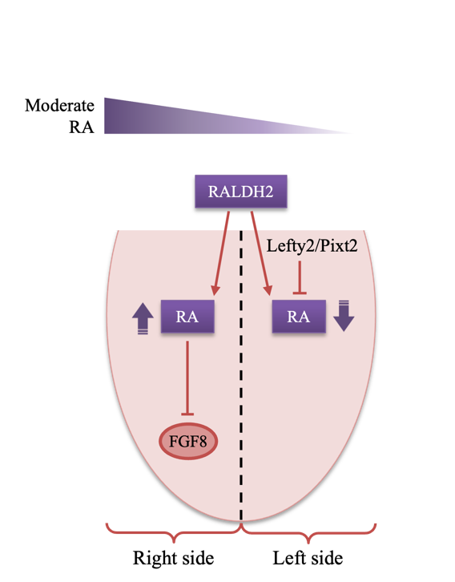
Figure 3
Asymmetric retinoic acid (RA) signaling in early heart field patterning.
Figure 4
Dose-dependent effects of retinoic acid (RA) on cardiac lineage specification.
Different concentrations of RA influence the differentiation trajectory of cardiac progenitors.
RA also plays a critical role in modulating the left-right patterning of the heart in vivo (Figure 3) [52, 56]. During late gastrulation, elevated calcium ion signaling on the left side induces Lefty2 and Pitx2 expression in the left lateral plate mesoderm (LPM) under the control of Nodal, which guides the determination of the left ventricle fate [57, 58]. To maintain this asymmetry, RA accumulates asymmetrically between the left and right heart fields, with higher levels on the right side. This right-sided RA pool, synthesized by RALDH2, acts to suppress inappropriate left-sided signals and limits FGF8 expression, especially in the SHF, thereby preventing overexpansion of cardiac progenitor region [59-61].

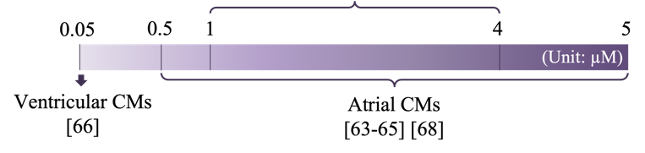
Given RA's pivotal role in SHF restriction and chamber specification, its concentration is a crucial for shaping cardiomyocyte subtype outcomes (Figure 4), whearas low RA means overexpansion of SHF, and high RA means repression of SHF as assayed by decreasing located FGF8 level and down regulation of Tbx1 [60, 62]. Previous research has demonstrated that atrial cardiomyocyte differentiation is enhanced by RA concentrations between 1–5 µM [63-65], while 0.05 µM RA promotes left ventricular cardiomyocyte specification [66]. Additionally, some studies still suggested that 1–4 µM RA favors epicardial cell induction in most cases [67], and 0.5–1 µM RA increases atrial cardiomyocyte proportion [65, 68]. Importantly, timing also matters—low-dose RA during mesoderm induction is key to left ventricular cardiomyocyte fate [69-72].
1.5 Impact of cell passaging on differentiation outcomes
Although cell passaging is often regarded as a routine step for maintaining hESC cultures, emerging evidence suggests that the timing of passaging during differentiation can significantly influence lineage outcomes. Previous studies have reported that excessive passaging may reduce the differentiation potential of hESCs [73-75]. Interestingly, our lab’s unpublished observations indicate that performing a passage during the early stage of cardiac differentiation enhances cardiomyocyte yield. One possible explanation is that adjusting cell density through passaging helps reshape the local microenvironment, thereby modulating intercellular signaling and the distribution of essential growth factors and nutrients—factors known to play key roles in supporting the metabolic shift required for effective lineage commitment [76]. The effect of cell density on the differentiation efficiency of cardiac cells is different or controversial, high density is conducive to signaling between cells and unifying cell differentiation progress to improve purity, while single cells in low density can obtain more nutrient resources and is more conducive to cell growth [77-79].

1.6 Markers for Cardiomyocyte Identification
Several markers have been identified to distinguish these progenitor populations. TBX5 [80, 81], HCN4 [16] and NKX2-5 [13, 82, 83] are known to be expressed in FHF progenitors, whereas ISL1 is specific to SHF progenitors [50, 84-86]. Ventricular cells are characterized by high expression levels of MLH7 and MYL2 [14, 87], whereas atrial cells exhibit elevated expression of NR2F2, NPPA and MYH6 [69, 88], allowing clear differentiation between ventricular and atrial myocytes. However, distinguishing between left and right ventricular myocytes is more challenging. Left and right ventricular cells differ in their structural, metabolic, calcium-handling, and electrophysiological properties and originate from distinct cardiac populations [13, 16]. A summary of gene markers for subtype identification of cardiac cells is provided in Table 1.

Comparison | Cell type | Gene Marker
FHF vs. SHF | FHF | TBX5*, HAND1*, NKX2.5*, HCN4*
FHF vs. SHF | SHF | ISL1*, TBX1*, PITX2*, FGF8*, FGF10*, ALDH1A2*
LV vs. RV (Fetal) | LV cardiomyocytes | TBX5#*, HCN4#*, NKX2.5#*, HAND1*, HEY2*
LV vs. RV (Fetal) | RV cardiomyocytes | TBX20#*, ISL1#*, FGF8*, FGF10*, TBX1*
Atria vs. Ventricle (Fetal) | Atrial cardiomyocytes | MYH6#*, NPPA#*, NR2F2#*
Atria vs. Ventricle (Fetal) | Ventricular cardiomyocytes | MYH7#*, MYL2#*
Table 1
Validated gene markers for distinguishing cardiac subtypes during development.
This table summarizes representative gene markers used to distinguish first and second heart field (FHF vs. SHF), left and right ventricular cardiomyocytes (LV vs. RV), and atrial versus ventricular cardiomyocytes during fetal development.
Note. Asterisks (*) indicate markers validated in animal models. Hash symbols (#) indicate markers validated in human fetal heart single-cell transcriptomic datasets.
Adapted from Zhao et al. [1], Paige et al. [2], Yang et al. [6], and Galdos et al. [7].

2. Method

2.1 Human embryonic stem cells maintenance
Human embryonic stem cells (hESCs, passages 30–50) were used in this study. H1 cells were maintained in Essential 8 (E8) medium on Matrigel-coated 6-well plates, following standard culture conditions (37°C, 5% CO₂) with daily medium replacement. The detailed composition of the E8 medium is provided in Table S2 [89]. Cells were passaged every three days at a ratio of 1:8 to 1:12 once they reached 60–80% confluency. For passaging, cells were dissociated using an EDTA solution supplemented with 5 μM Y-27632 (ROCK inhibitor).
2.2 Cardiac differentiation from hESC
Differentiation was initiated on Day 0, defined as the time of CHIR99021 treatment. Human embryonic stem cells (hESCs) were seeded at ~30% confluency (around 26,000 cells/cm²) and maintained in E8 medium for two days (Day -2 to Day -1) as a monolayer. On Day 0, cells were treated for 24–26 hours with either 5 µM CHIR99021 alone or in combination with 10 ng/mL BMP4, both prepared in differentiation medium (DFM), which consists of E5 medium supplemented with 1% CD Lipid). After this initial induction, CHIR99021 and BMP4 were removed, and cells were maintained in DFM alone, with or without 100 nM LDN-193189.

For cultures that were not passaged, 1 µM IWR1 was added from Day 2 to Day 4 to support cardiac lineage commitment. If cells were 1:6 passaged on Day 2, IWR1 treatment was shifted to Day 3–4. In cases where a second passage occurred on Day 2, Wnt inhibition could be skipped depending on the experimental setup. From Day 2 onward, 1 mg/L insulin was added based on cell growth. All differentiation steps were performed on Matrigel-coated plates (10 µg/cm²) under adherent culture conditions.

2.3 Flow cytometry analysis
Human ESCs were dissociated into single cells using TrypLE Select, then neutralized with either 5% fetal bovine serum (FBS) or 2% bovine serum albumin (BSA). Cells were centrifuged at 400 ×g for 5 minutes and washed three times with 1×PBS. For each experiment, approximately 5 × 10⁵ to 10⁶ cells were counted using a hemocytometer. Fixation was performed using 1% paraformaldehyde (PFA) at 37˚C for 10 minutes, followed by permeabilization with 90% ice-cold methanol on ice for 30 minutes. Cells were then incubated with primary antibodies either overnight at 4°C or for 1 hour at room temperature. Fluorescently labeled secondary antibodies were applied for 1 hour in the dark at room temperature. After three PBS washes, cell suspensions were filtered through a strainer to remove clumps before flow cytometry.

2.4 Immunofluorescence staining
Cells were fixed in 4% PFA for 15 minutes at room temperature, then blocked and permeabilized in PBST containing 2% BSA and 0.5% Triton X-100. Primary antibodies were added and incubated overnight at 4°C. After washing, Alexa Fluor®-conjugated secondary antibodies (1:1000, Jackson ImmunoResearch) were applied for 30–60 minutes at room temperature in the dark. Nuclei were counterstained with Hoechst 33342 (1:5000 in PBS) for 10 minutes. Fluorescent images were taken using the EVOS Cell Imaging System (Thermo Fisher Scientific) after two final PBS washes.

2.5 Confocal microscopy
Approximately 5 × 10⁴ cells were seeded onto confocal dishes and cultured in DFM, 10 µM Y-27632 (ROCK inhibitor), and 1 ng/mL insulin (Sigma, 19278). Following passaging, cells were allowed to adhere and recover for one day before fixation. Cells were fixed with 4% paraformaldehyde (PFA) for 15 minutes at room temperature, then permeabilized and blocked in PBS containing 2% BSA and 0.5% Triton X-100 (in PBST). Subsequently, cells were incubated overnight at 4°C with a primary antibody against β-actin, followed by incubation with an Alexa Fluor 488-conjugated secondary antibody (Thermo Fisher) for 1 hour at room temperature in the dark. Nuclei were counterstained with 4',6-diamidino-2-phenylindole (DAPI) for 10 minutes at room temperature. Confocal images were acquired using a Zeiss LSM 710 laser scanning confocal microscope. All imaging parameters, including laser intensity, gain, and exposure time, were kept constant across all experimental groups to ensure comparability. Representative fields were captured for each condition.

2.6 Quantitative PCR analysis
Total RNA was extracted from hESC-derived cardiomyocytes (hESC-CMs) using either TRIzol Reagent or RNAiso Plus (Takara, #9109), following the manufacturer’s instructions. For each sample, 1000 ng of RNA was collected from a single well of a 12-well plate. Reverse transcription was performed using the Maxima H Minus Reverse Transcription Kit (Applied Biosystems, #4368814) in a 10 μL reaction, under standard conditions: 94°C for 30 s, 60°C for 30 s, and 72°C for 1 min over 35 cycles, followed by a final extension at 72°C for 7 min. The resulting cDNA was diluted 1:5 with ultrapure water and used as the template for qRT-PCR.

Quantitative PCR was carried out on a CFX384 Touch Real-Time PCR Detection System (Bio-Rad) using ChamQ Universal SYBR qPCR Master Mix (Vazyme, Q711-03). All reactions were run in duplicate. Cycling conditions were: 95°C for 10 min, followed by 40 cycles of 95°C for 15 s, 60°C for 1 min, and 72°C for 15 s. Gene expression levels were calculated using the 2^−ΔCT method, with GAPDH or TBP used as internal reference genes. Primer sequences are provided in Table S1.

2.6 Western blot analysis
Proteins from each 12-well plate were lysed in 70 µL of Laemmli buffer containing 62.5 mM Tris-HCl (pH 6.8), 25% glycerol, 2% SDS, 0.01% bromophenol blue, and 0.4% (v/v) benzonase. Protein concentrations were measured using the BCA assay and adjusted to 0.2–2 μg/μL, with PBS used for dilution when needed. Samples were denatured by heating at 100°C for 2–5 minutes in a metal block. Proteins were separated on 10–15% SDS-PAGE gels, starting at 80 V for 20–45 minutes through the stacking gel, followed by 120 V for about 1 hour through the resolving gel. Wet transfer onto membranes was performed using methanol-containing transfer buffer, either at 100 V for 60–90 minutes or at 30 V overnight at 4°C. Membranes were blocked with 5% non-fat milk and 1% BSA in TBS-T (0.1% Tween-20) for 1 hour at room temperature. Primary antibody incubation was carried out overnight at 4°C with gentle rocking. After three washes in TBS-T, membranes were incubated with secondary antibodies, and signal was visualized using a Bio-Rad imaging system. All protein bands were normalized to β-actin for quantification.

3. Result
The impact of Day 2 passaging on cardiomyocyte differentiation was examined through morphological assessment and gene expression analysis. By Day 10, cultures that underwent passaging displayed a more homogeneous, sheet-like monolayer morphology, whereas non-passaged cells showed uneven differentiation and frequent retention of undifferentiated regions (Figure 5B, left vs. middle). Passaged cells treated with BMP4/LDN-193189 also exhibited similarly uniform cardiac morphology, suggesting that this treatment did not diminish the beneficial effects of passaging (Figure 5B, right).

Transcriptional analysis further confirmed that passaging promoted cardiac identity. Expression levels of cardiomyocyte markers TNNT2, TNNT3, and MYL2 were increased in passaged cultures compared to non-passaged controls (Figure 5C), indicating enhanced differentiation efficiency and improved cellular purity. This observation is further supported by unpublished data from our laboratory, which consistently demonstrate improved cardiomyocyte yield and uniformity following Day 2 passaging.

Mechanistically, passaging at this stage may help redistribute cell density more evenly across the culture surface, thereby reducing localized nutrient depletion and promoting uniform exposure to differentiation signals. This synchronization likely contributes to improved lineage commitment and the generation of a more consistent cardiomyocyte population.

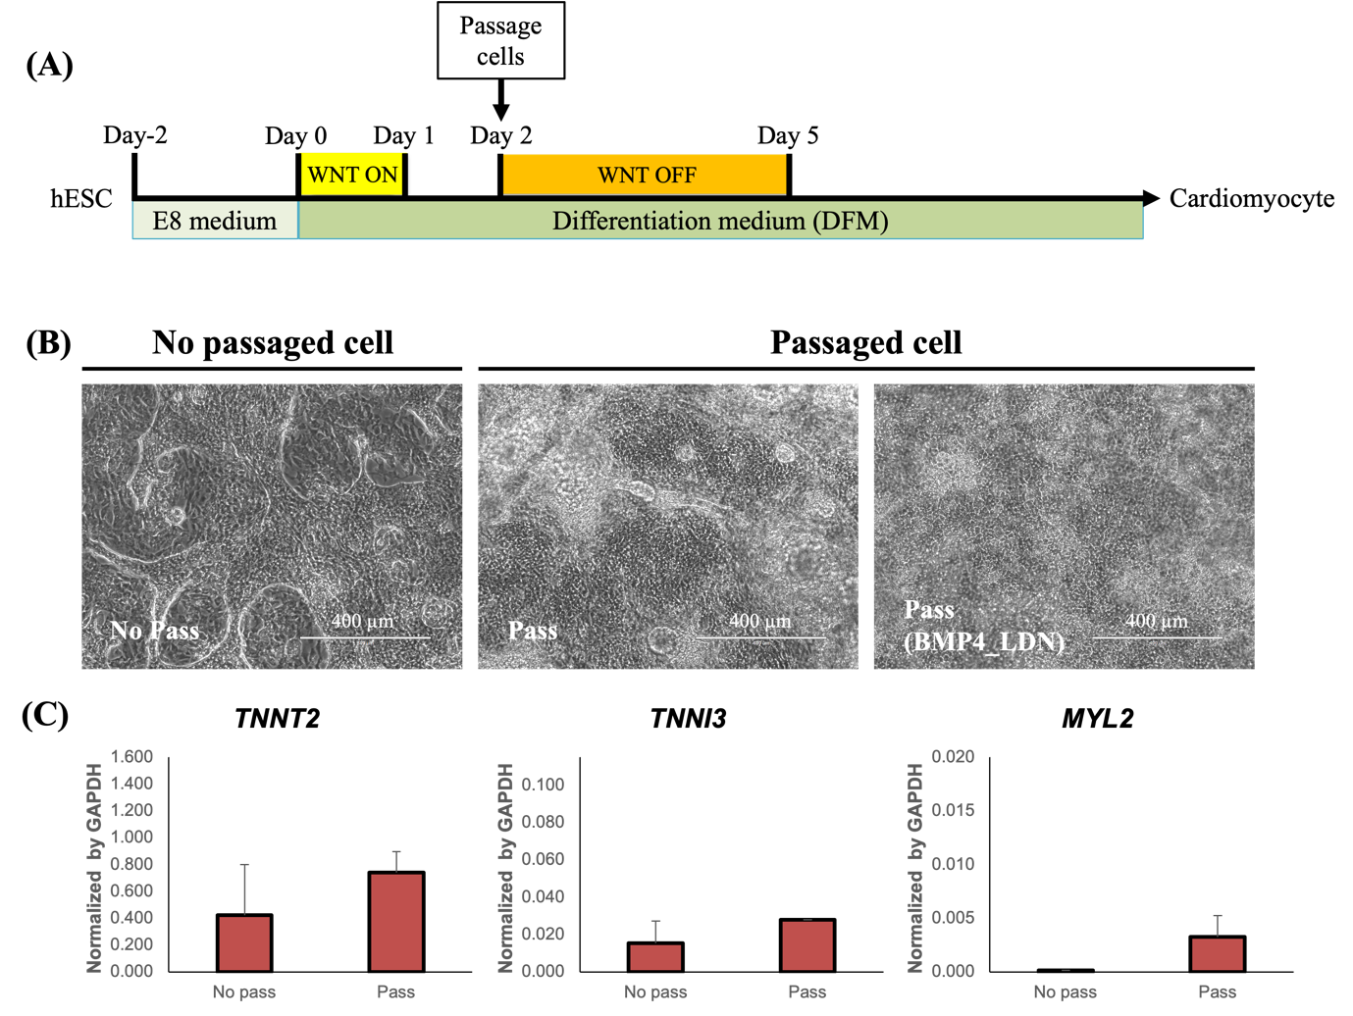

Figure 5
Day 2 passaging promotes more efficient and homogeneous cardiomyocyte differentiation.
(A) Schematic of the baseline WNT ON/OFF differentiation protocol. hESCs were treated with 5 µM CHIR99021 (WNT activator) on Day 0 to initiate mesoderm induction. Cells were either passaged at a 1:6 ratio on Day 2 or cells maintained without passaging. For WNT inhibition, 1 µM IWR-1 was added for 2 days: in unpassaged cells starting from Day 2, and in passaged cells starting from Day 3. DFM: differentiation medium (E5 medium supplemented with 1% CD lipid).
(B) Brightfield images (top) and qRT–PCR analysis (bottom) comparing non-passaged (No Pass), passaged (Pass), and passaged with BMP4/LDN-193189-treated (Pass BMP4_LDN) hESC cultures. BMP4_LDN: BMP4 (10 ng/mL) treatment on Day 0 and LDN-193189 (100 nM) treatment on Day 1. By Day 10, cells that underwent passaging on Day 2 displayed more uniform monolayer morphology and fewer undifferentiated regions compared to non-passaged cultures.
(C) Relative expression levels of cardiomyocyte markers TNNT2, TNNT3, and MYL2 were higher in the passaged group, indicating enhanced cardiac purity and maturation. Data represent mean ± SD from two technical replicates.
3.1 Combination of BMP4 and LDN-193189 enhances SHF cell specification
As observed in Figure 6, BMP4 treatment on Day 0 induced an expanded and flattened colony morphology by Day 1, suggesting early changes in epithelial organization that may influence differentiation dynamics. Building on this observation, a stepwise protocol incorporating BMP4 activation on Day 0 and LDN-193189–mediated inhibition on Day 1 was employed. This strategy appeared to improve morphological consistency across different cell confluence prior to CHIR99021 exposure (data not shown) and CHIR99021 exposure durations (Figure 7).

BMP4/LDN-193189 treatment led to a transcriptional shift favoring SHF identity. On Day 5, expression of SHF-associated genes ISL1, FGF10, and ALDH1A2 was strongly upregulated, while FHF markers TBX5, HCN4, and HAND1 were downregulated (Figure 8A–B). By Day 10, ISL1 remained elevated and TBX5 stayed suppressed, whereas TNNT2, a pan-cardiac marker, showed minimal change (Figure 8C). Immunofluorescence staining confirmed these trends at the protein level (Figure 9). TBX5 expression was weaker, in BMP4/LDN-treated cells compared to controls, both at Day 5 and Day 10. These results point to a sustained bias toward SHF lineage under BMP4/LDN-193189 modulation.

Compared to the control group, the BMP4/LDN-193189-treated cells formed a dense and uniform monolayer of cardiomyocytes earlier—by Day 7—indicating enhanced purity of differentiation (Figure 10A). By Day 20, both groups exhibited mature cardiomyocyte morphology, although cells in the BMP4/LDN-193189 group appeared to have slightly wider intercellular spacing. However, expression analyses performed on Day 10 and beyond (data not shown) did not provide strong evidence that BMP4/LDN-193189 further promoted cardiomyocyte maturation at later stages. Additionally, while cells in the control group frequently displayed vacuolated regions, those treated with BMP4/LDN-193189 maintained more compact structures, suggesting that the treatment may promote cardiomyocyte survival or proliferation, resulting in an overall increase in cardiomyocyte number.

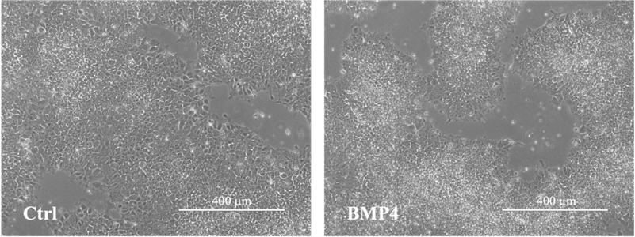
Although TNNT2 mRNA levels were slightly lower in the BMP4/LDN-193189 group compared to controls, flow cytometry analysis showed comparable TNNT2 protein expression between groups (Figure 10B & 10C). This indicates that despite the lower transcript levels, the BMP4/LDN-193189 protocol yields high-quality cardiomyocytes that exhibit typical morphology earlier than controls. These results also suggest that qPCR might not fully reflect intracellular levels of structural proteins like TNNT2 under these conditions.
Figure 6
BMP4 treatment on Day 0 promotes colony spreading, potentially supporting higher confluence tolerance and consistent differentiation.
Brightfield images of control and 10 ng/mL BMP4-treated hESC-derived cardiomyocytes. BMP4-treated colonies display more flattened cells at the periphery, with visible migration away from the colony edge, consistent with EMT-like morphological changes. Scale bar = 400 μm.
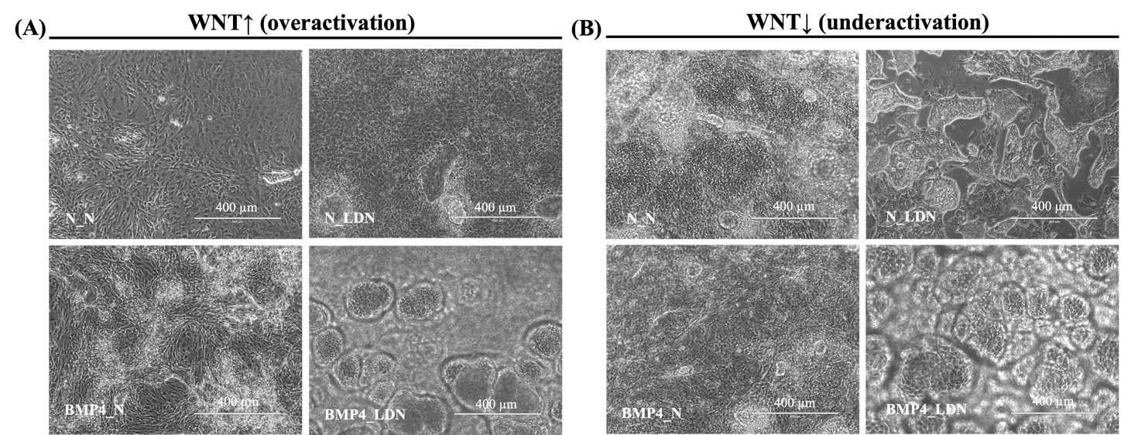
Figure 7
Brightfield images on Day 10 showing the effect of BMP4/LDN-193189 treatment on cardiomyocyte differentiation under varying WNT signaling conditions.
(A) Under WNT overactivation, the N_N group showed elongated, spindle-shaped cells resembling fibroblasts, while N_LDN formed loosely packed, disorganized monolayers. BMP4_N led to partial compaction with mixed morphologies, and BMP4_LDN promoted dense, rounded colonies with radial alignment, resembling early cardiomyocytes.
(B) Under WNT underactivation, both N_N and BMP4_N mostly displayed flattened, epithelial-like cells with poor organization. N_LDN showed slight colony formation, whereas BMP4_LDN induced more compact, circular structures suggestive of cardiac sheet-like organization. Functional assays were not performed for low-efficiency groups due to poor cell recovery.

Note.
All groups underwent standard WNT ON/OFF modulation and were 1:6 passaged on Day 2. The experimental groups were treated with BMP4 and LDN-193189, while the other three groups did not receive 10 ng/mL BMP4 (Day 0) or 100 nM LDN-193189 (Day 1). In both contexts, N_N (no BMP4 and LDN-193189 treatment) , BMP4_N (BMP4 added on Day 0 without LDN-193189 added on Day 1) and N_LDN (without BMP4 added on Day 0 but with LDN-193189 added on Day 1) resulted in heterogeneous and unstable differentiation outcomes. In contrast, BMP4_LDN (BMP4 activation on Day 0 followed by LDN-193189 inhibition on Day 1) consistently yielded well-compacted, morphologically homogeneous cardiomyocyte-like clusters, indicative of enhanced differentiation robustness across variable WNT signaling states.
Due to poor differentiation efficiency, no RNA or cell samples were collected for downstream validation in these conditions. Thus, these observations remain morphological and are not supported by molecular data.

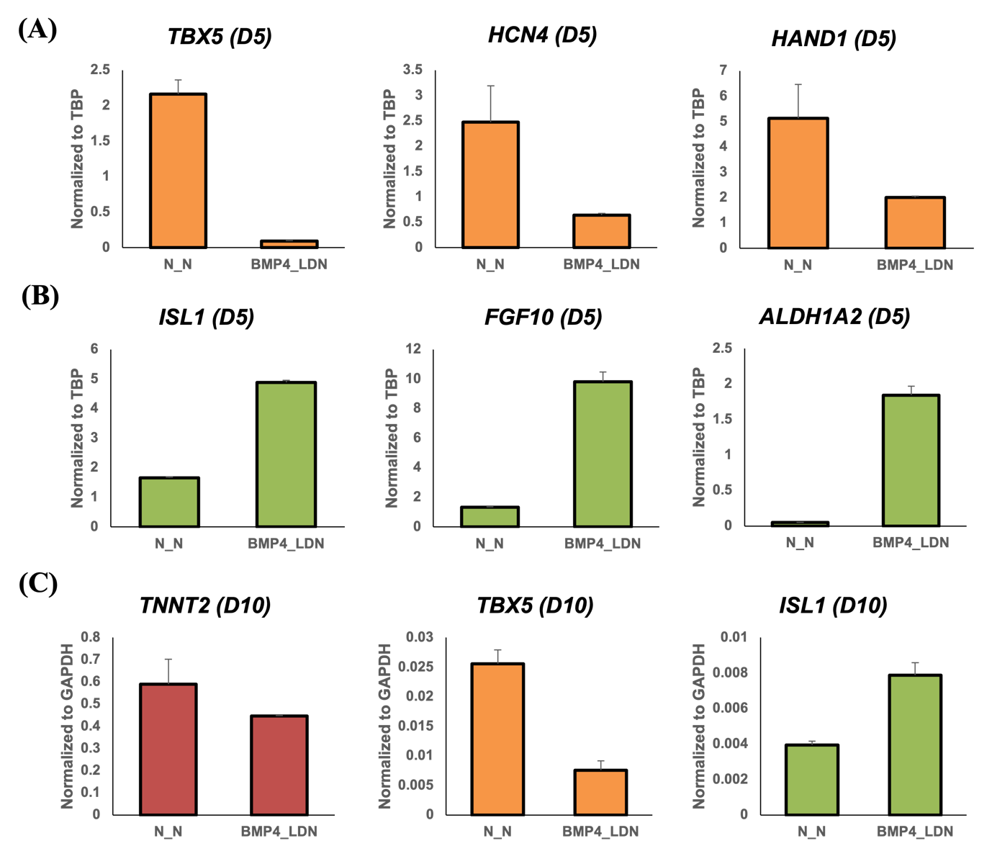
Figure 8
BMP4/LDN-193189 suppresses FHF markers and induces SHF-associated gene expression during early cardiac specification.
Quantitative RT–PCR analysis was performed to assess the impact of 10 ng/mL BMP4 followed by 100 nM LDN-193189 -mediated inhibition on early cardiac lineage specification. Data represent mean ± SD from two technical replicates. BMP4_LDN: BMP4 (10 ng/mL) treatment on Day 0 and LDN-193189 (100 nM) treatment on Day 1.
(A) On Day 5 (D5), expression of FHF markers TBX5, HCN4, and HAND1 was reduced under BMP4/LDN-193189 treatment compared to untreated (N_N) conditions.
(B) In contrast, SHF-associated markers ISL1, FGF10, and ALDH1A2 were significantly upregulated, indicating enhanced SHF specification.
(C) By Day 10 (D10), reduced expression of TBX5 and increased expression of ISL1 persisted, while the pan-cardiac marker TNNT2 showed minimal variation.

Note. All groups underwent standard WNT ON/OFF modulation and were 1:6 passaged on Day 2. The experimental groups (BMP4_LDN) were treated with 10 mg/mL BMP4 and 100 nM LDN-193189, while the control groups (N_N) without either BMP4 or LDN-193189 treatment.

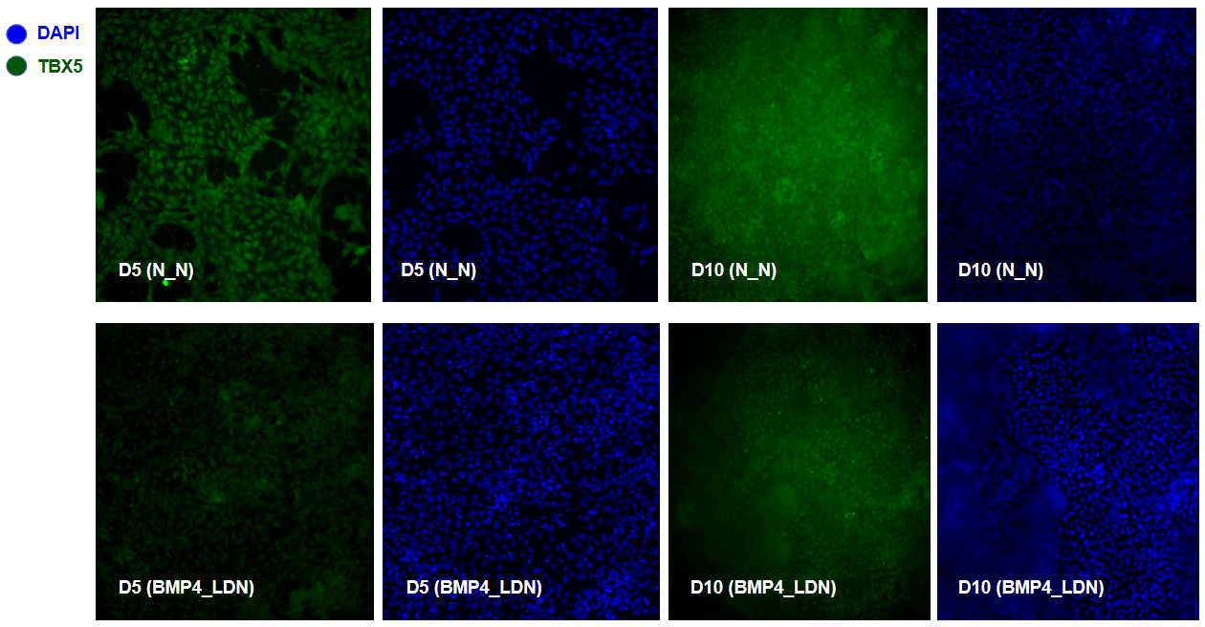
Figure 9
BMP4/LDN-193189 treatment promotes sustained SHF-like identity by reducing TBX5 expression.
Representative immunofluorescence images showing TBX5 (green) and DAPI (blue) staining under control (N_N) and BMP4/LDN-treated conditions. On both Day 5 and Day 10, TBX5 expression was prominent in untreated cells, consistent with first heart field (FHF) identity. In contrast, BMP4 activation followed by LDN-193189 inhibition resulted in reduced TBX5 signal, confirming second heart field (SHF) fate specification under this treatment. BMP4_LDN: BMP4 (10 ng/mL) treatment on Day 0 and LDN-193189 (100 nM) treatment on Day 1.

Note. All groups underwent standard WNT ON/OFF modulation and were 1:6 passaged on Day 2. The experimental groups (BMP4_LDN) were treated with 10 mg/mL BMP4 and 100 nM LDN-193189, while the control groups (N_N) without either BMP4 or LDN-193189 treatment.

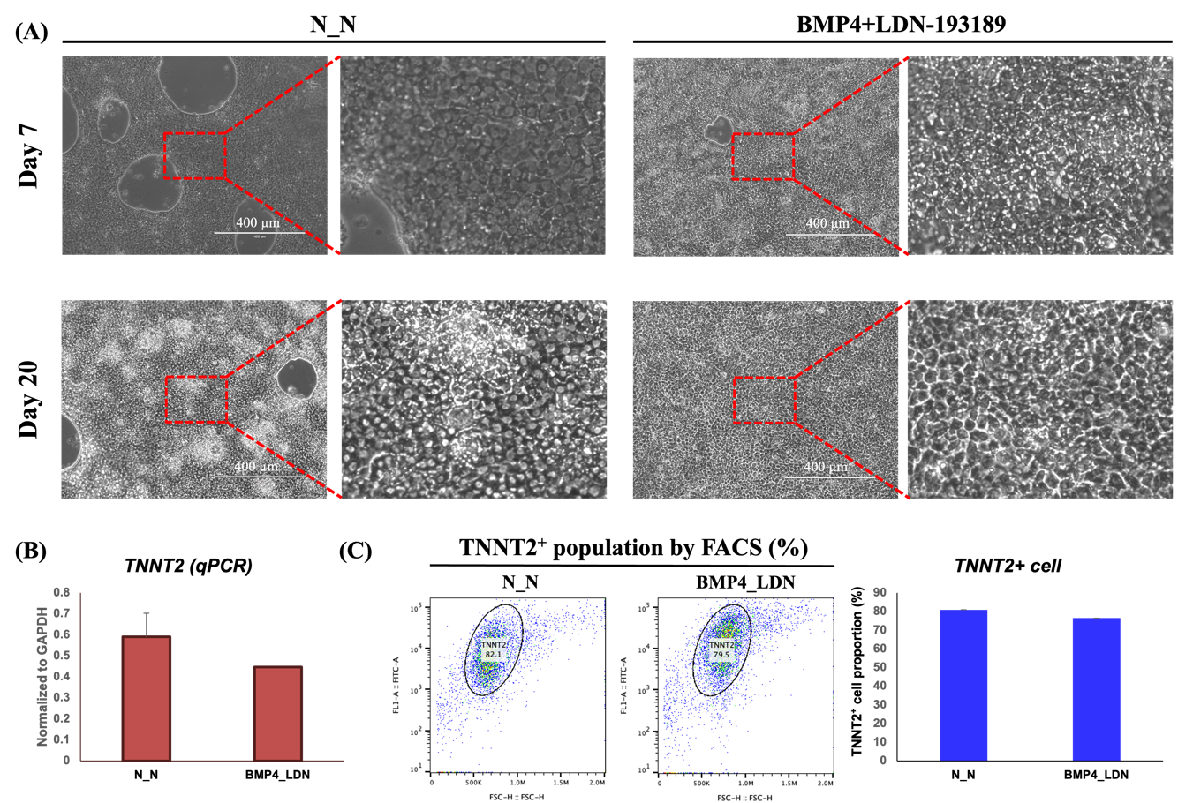

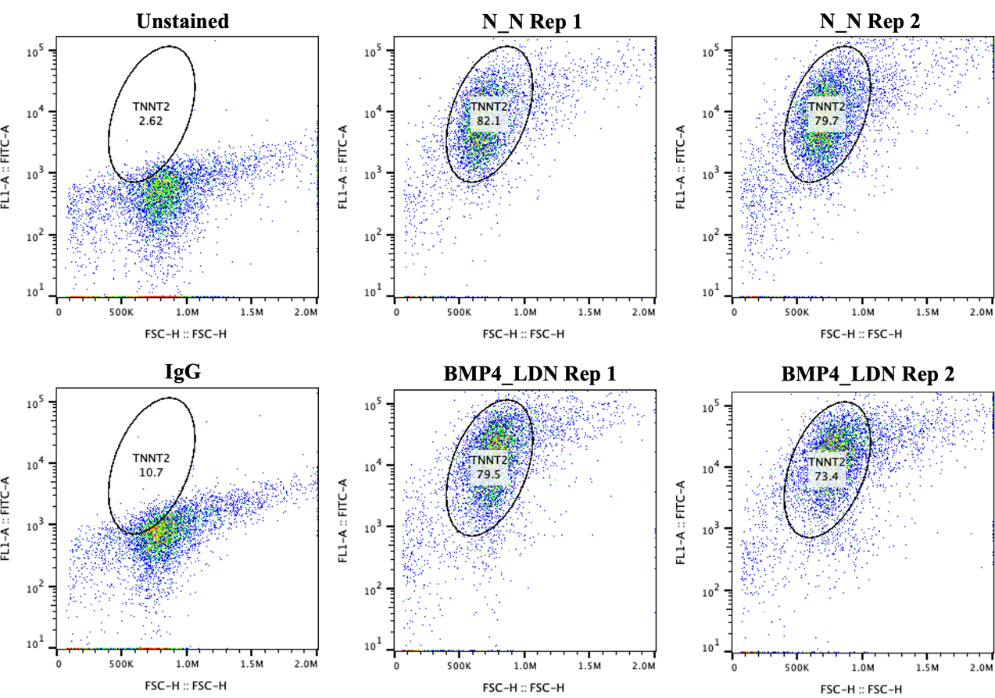
(D)
Figure 10
BMP4/LDN-193189 maintains high TNNT2 protein expression despite reduced mRNA levels.
(A) Brightfield images of control and BMP4- and LDN-193189-treated cells at Day 7 (top) and Day 20 (bottom). For each condition, the left panel shows the original field (scale bar: 400 μm), and the right panel displays a manually magnified view (~3.8×) of the boxed region to visualize cellular morphology. At Day 7, control cells (N_N) exhibit moderate compaction, relatively regular cell boundaries, and uniform sizes, whereas cells treated with BMP4 and LDN-193189 appear rounder, more dispersed, and morphologically heterogeneous. At Day 20, control cells form a well-organized, mature monolayer with tightly packed and polygonal shapes, consistent with advanced structural maturation. In contrast, cells treated with BMP4 and LDN-193189, though still confluent, show increased clustering, less uniform cell size, and reduced alignment. Comparatively, control cells demonstrate higher maturity, orderly arrangement, uniform shape, and tight intercellular connectivity, while BMP4- and LDN-193189-treated cells show signs of delayed morphological organization.
(B) qRT-PCR quantification of TNNT2 expression normalized to GAPDH. Data represent mean ± SD from two biological replicates, each with two technical replicates.
(C) Representative flow cytometry plots (left) and quantification (right) of TNNT2⁺ cardiomyocytes under control (N_N) and BMP4- and LDN-193189-treated conditions. Data represent mean ± SD from two biological replicates. The Y-axis (FITC-A) is plotted on a logarithmic scale, while the X-axis (FSC-H) is linear. Full flow cytometry plots for both replicates, including unstained and IgG controls, are provided in (D) below.
(D) Flow cytometry analysis of TNNT2 expression on Day 10 of cardiomyocyte differentiation. Representative dot plots showing TNNT2 (cTnT) staining in cells treated with or without BMP4/LDN-193189. Unstained and IgG controls were included to define background fluorescence and nonspecific binding. Ctrl Rep 1 and 2 (N_N treatment) showed high TNNT2 positivity (82.1% and 79.7%, respectively), while BMP4_LDN-treated cells showed comparable TNNT2+ populations (79.5% and 73.4% for Rep 1 and 2). The Y-axis (FITC-A) is plotted on a logarithmic scale, while the X-axis (FSC-H) is linear.

Note. All groups underwent standard WNT ON/OFF modulation and were 1:6 passaged on Day 2. The experimental groups (BMP4_LDN) were treated with 10 mg/mL BMP4 and 100 nM LDN-193189, while the control groups (N_N) without either BMP4 or LDN-193189 treatment.
3.2 Dosing and timing of RA influence in cardiomyocyte differentiation
RA Dosing Influences Subtype Specification of Cardiomyocytes
As shown in Figure 11A, C, and D, low-dose RA (0.1 μM) promoted ventricular identity, as evidenced by elevated MYL2 and MYH7 expression, while high-dose RA (0.5 μM) upregulated atrial gene expression, indicating a dose-dependent influence on chamber-specific identity. TNNT2 expression remained consistently high across all conditions, confirming successful cardiomyocyte commitment regardless of RA concentration. Immunofluorescent staining for α-actinin further (green) revealed well-organized sarcomeric structures in both RA-treated groups (Figure 12), indicating that two-day RA exposure from Day 3 to Day 5 is sufficient to initiate structural organization during early cardiomyocyte differentiation.

In contrast, exposure to high concentrations of RA (1–2 μM) completely abolished cardiomyocyte differentiation under the WNT ON/OFF-based protocol, as evidenced by the absence of spontaneously beating clusters and loss of characteristic cardiac morphology (Figure 11B). qRT-PCR analysis of further revealed several elevated expression of fibroblast-associated genes (data not shown), suggesting a potential lineage diversion toward fibroblast-like cells under excessive RA exposure, which is corresponding with the previous finding [67]. In addition, RA concentrations above 2 μM frequently caused extensive cell loss, leading to overt cytotoxicity and ultimately failure of cardiomyocyte differentiation.

Based on these results, 0.1 μM RA administered over two days (Day 3–5) was selected as the standard concentration for subsequent experiments, as it consistently promoted ventricular cardiomyocyte differentiation without inducing off-target lineages. Interestingly, a single dose of 0.1 μM RA on Day 4 exhibited an opposite trend, with increased expression of atrial-associated markers (Figure 13A), suggesting that timing and duration of RA exposure critically influence chamber-specific outcomes. However, this chamber-specification effect from single-dose RA was not sufficiently robust or consistent across replicates to drive clear atrial versus ventricular segregation.

RA timing selectively influences cardiomyocyte maturation
This study also examined the effects of RA treatment at different developmental stages. RA applied during Day 5–10 did not result in consistent chamber-specific outcomes and, in some cases, appeared to impair cardiomyocyte maturation. Although a slight increase in MYL2 expression was observed in one dataset (Figure 13B), this contrasted with a broader downregulation of structural and metabolic markers—including MYL2—in a parallel experiment (Figure 14A), pointing to variability in the transcriptional response to RA during this period.

In contrast, RA treatment during Day 10–15 did not appear to influence subtype identity (data not shown) but instead enhanced cardiomyocyte maturation, as reflected by upregulated expression of genes involved in sarcomeric organization (ACTN2), calcium handling (RYR2, SERCA2), and metabolism (PGC1α, CPT1B) (Figure 14B).

Enhanced Chamber Specification via Combined RA and BMP/LDN-193189 Treatment
Since RA treatment alone is not consistently reliable enough to direct efficient atrial and ventricular cardiomyocyte specification, supplementing it with the SHF-promoting BMP4/LDN-193189 strategy may further facilitate chamber-specific differentiation (Figure 15A & 15B). Preliminary data indicate that RA at 0.1 μM, and particularly at 0.5 μM, promotes atrial differentiation, confirmed by the upregulation of atrial-specific markers (Figure 15C).

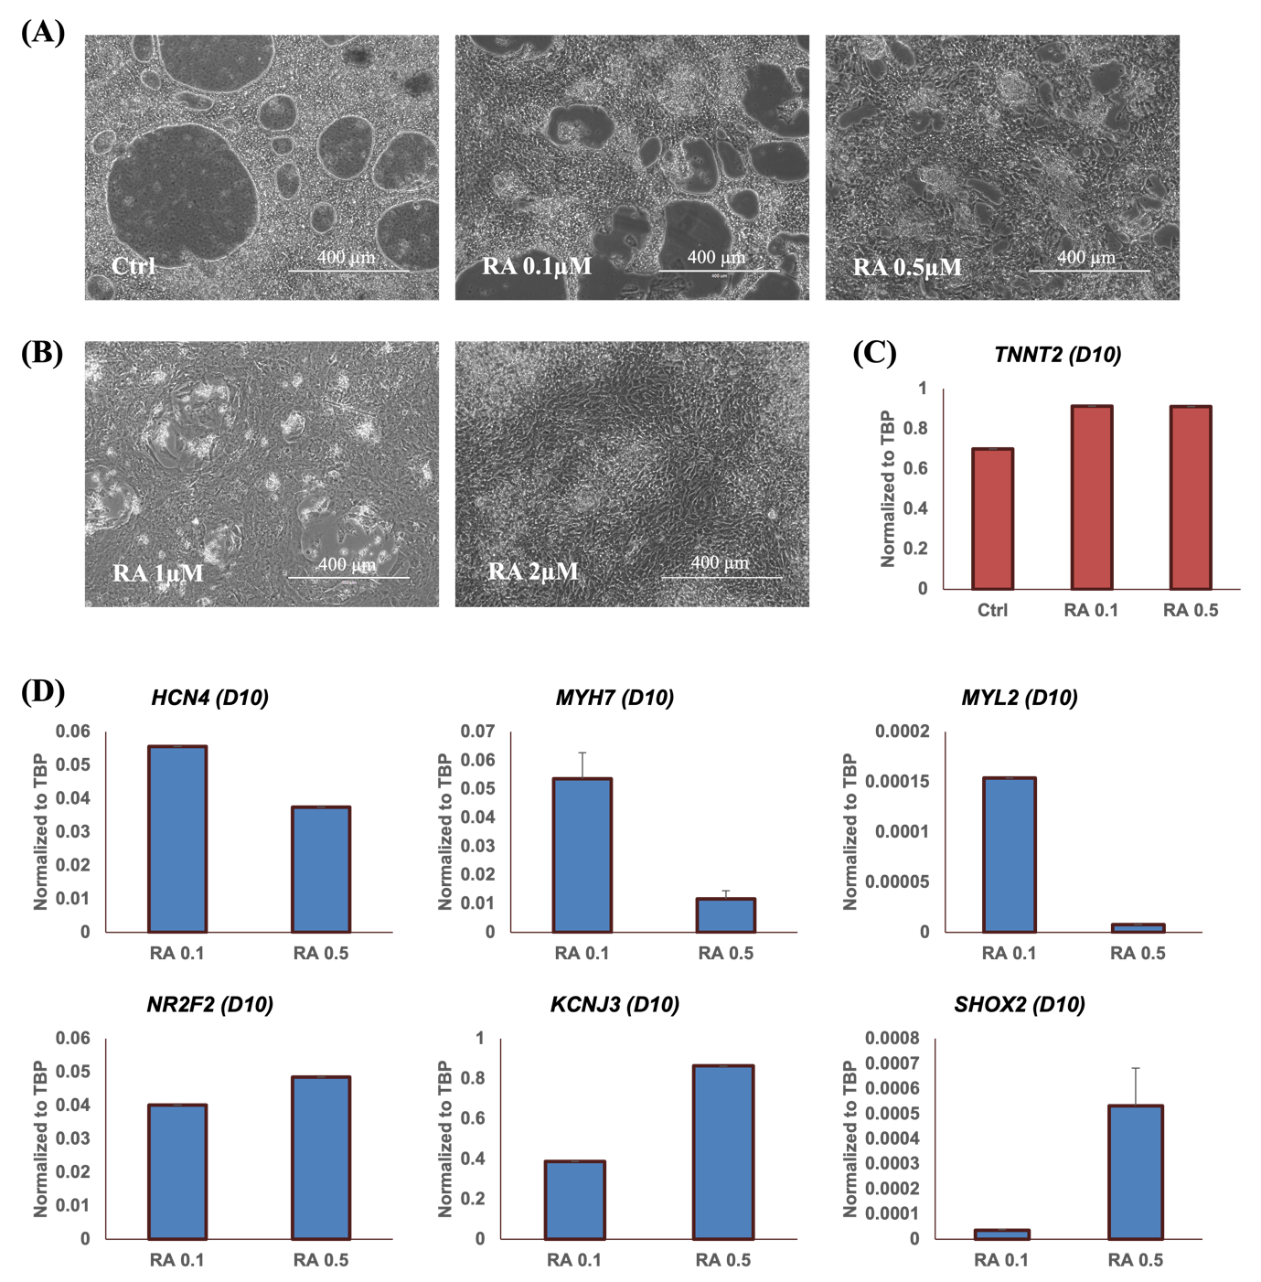
Figure 11
Dose-dependent effects of sustained RA treatment on cardiomyocyte morphology and gene expression.
(A) Brightfield images of cells treated with RA (0.1 μM, 0.5 μM, 1 μM, 2 μM) for 2 days, from Day 3 to Day 5, captured on Day 10. Low to moderate RA concentrations (0.1–0.5 μM) produced compact, cardiomyocyte-like clusters. In contrast, high-dose RA (1–2 μM) led to flattened, disorganized morphology and loss of contractile appearance. Scale bar = 400 μm.
(B) Cells treated with 1–2 μM RA failed to form beating clusters; unshown qRT-PCR analysis indicated upregulation of fibroblast marker, suggesting non-cardiac lineage diversion. Scale bar = 400 μm.
(C) TNNT2 expression confirming cardiomyocyte identity across 0.1 and 0.5 μM RA conditions. Data represent mean ± SD from two technical replicates.
(D) Relative expression of ventricular markers (MYH7, MYL2) and atrial markers (NR2F2, KCNJ3, SHOX2) under RA 0.1 and 0.5 μM conditions, showing dose-dependent subtype specification. Data represent mean ± SD from two technical replicates.

Note. All groups underwent standard WNT ON/OFF modulation and were 1:6 passaged on Day 2. The experimental groups (BMP4_LDN) were treated with 10 mg/mL BMP4 and 100 nM LDN-193189, while the control groups (N_N) without either BMP4 or LDN-193189 treatment.

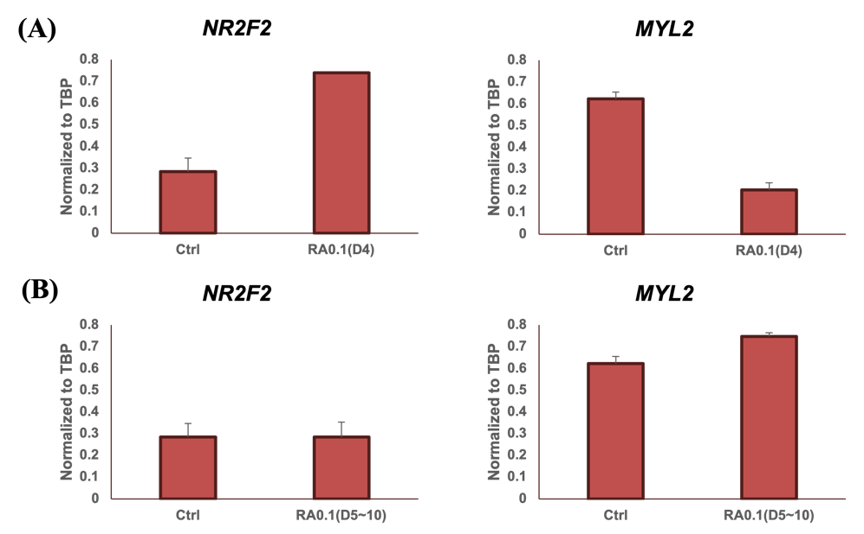
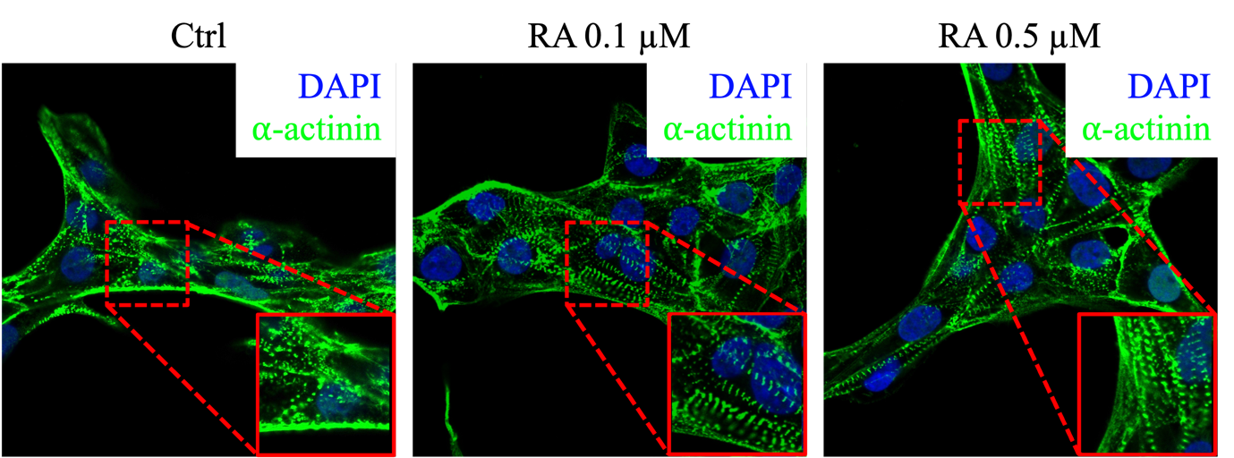
Figure 13
Chamber-specific differentiation is selectively induced by early RA exposure.
(A) A single 0.1 μM RA dose administered on Day 4 led to increased expression of NR2F2 (atrial marker) and reduced expression of MYL2 (ventricular marker) by Day 10, suggesting a shift toward atrial fate.
(B) In contrast, subtained RA treatment given later (Days 5–10) did not result in clear chamber-specific gene expression changes, indicating a reduced responsiveness to RA at this stage.

Note. All groups underwent standard WNT ON/OFF modulation and were 1:6 passaged on Day 2. Data are presented as mean ± SD from two technical replicates.

Figure 12
Immunofluorescence images of cardiomyocytes at Day 10 following RA treatment from Day 3 to Day 5.
Cells were treated with IWR1 alone or in combination with 0.1 μM or 0.5 μM RA. α-actinin (green) marks sarcomeric structure, and nuclei are stained with DAPI (blue). Increased RA concentration enhanced sarcomere organization and cellular alignment, indicative of dose-dependent structural maturation. Scale bar: 20 μm.

Note. All groups underwent standard WNT ON/OFF modulation and were 1:6 passaged on Day 2.

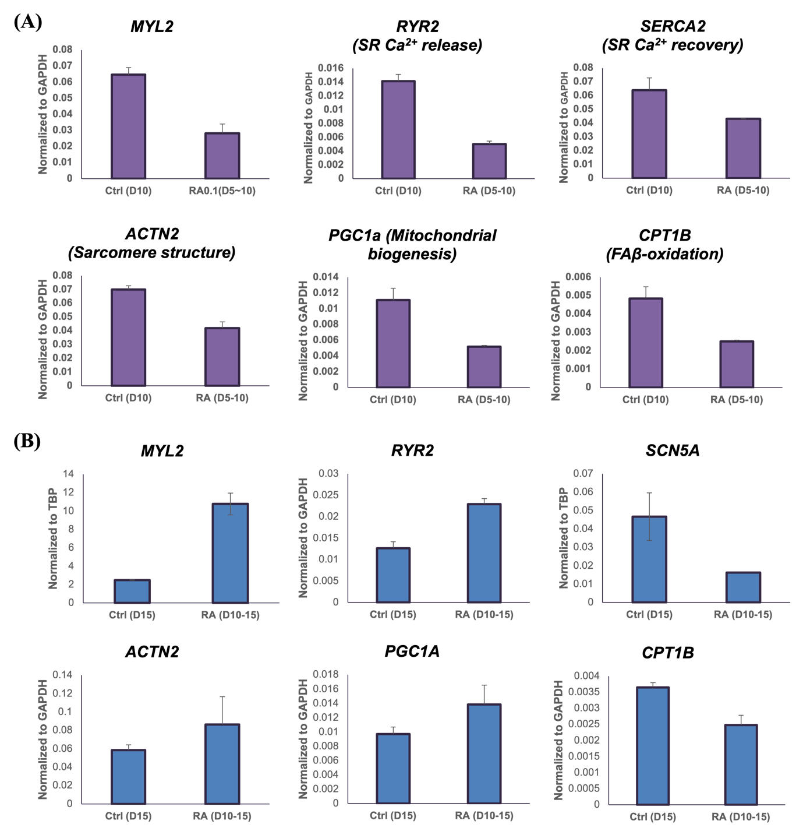
Figure 14
RA timing regulates cardiomyocyte maturation in a stage-dependent manner.
(A) Relative expression of genes associated with cardiac maturation, including sarcomeric structure (ACTN2, MYL2), calcium handling (RYR2, SERCA2), and metabolic activity (PGC1α, CPT1B) in cardiomyocytes harvested on Day 10 after RA treatment during Day 5–10. Gene expression was normalized to GAPDH.
(B) Relative expression of the same set of genes assessed on Day 15 following RA treatment during Day 10–15. MYL2 and RYR2 were normalized to TBP, while others were normalized to GAPDH.

Note. All groups underwent standard WNT ON/OFF modulation and were 1:6 passaged on Day 2. Data are presented as mean ± SD from two technical replicates.

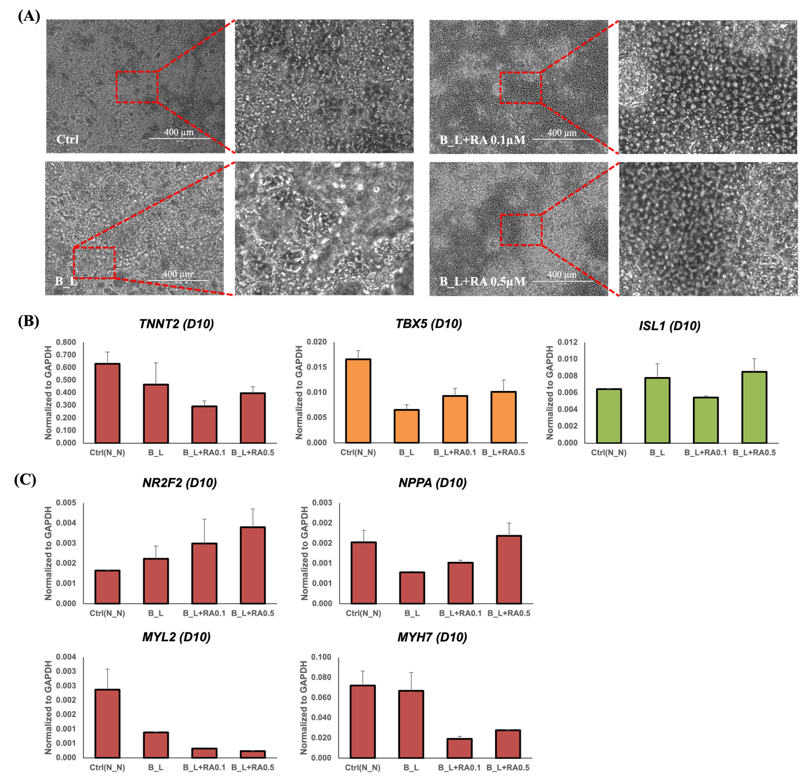

Figure 15
Atrial specification under combined RA and BMP4/LDN-193189 treatment.
(A) Day 10 brightfield images of control (N_N), cardiomyocytes treated with BMP4/LDN-193189 (B_L) alone or in combination with RA at 0.1 μM and 0.5 μM. For each condition, the left panel shows the original field (scale bar: 400 μm), and the right panel displays a manually magnified view (~3.8×) of the boxed region to visualize cellular morphology.
(B&C) Relative expression on Day 10 of chamber-specific markers was assessed by qRT-PCR in cardiomyocytes treated with BMP4/LDN-193189 (B_L) alone or in combination with RA at 0.1 μM and 0.5 μM. Gene expression was normalized to GAPDH. Data are presented as mean ± SD from two technical replicates. Cardiac cell marker: TNNT2. First heart field original cardiomyocyte marker: TBX5. Second heart field original cardiomyocyte marker: ISL1. Atrial markers: NR2F2, KCNJ3, SHOX2. Ventricular markers: MYL2, MYH7, IRX4.

Note. All groups underwent standard WNT ON/OFF modulation and were 1:6 passaged on Day 2. The experimental groups (B_L) were treated with 10 mg/mL BMP4 and 100 nM LDN-193189, while the control groups (N_N) without either BMP4 or LDN-193189 treatment. RA was treated for 6 days (Day 4-10).

4. Discussion

A small-molecule approach enables efficient and flexible cardiomyocyte differentiation
This study establishes a small-molecule-based protocol for the directed differentiation of human embryonic stem cells (hESCs) into defined cardiomyocyte subtypes. Early-stage activation of BMP4 followed by inhibition using LDN-193189 promotes the specification of second heart field progenitors (SHF) instead of first heart field (FHF), enabling the initial segregation of left and right cardiac lineages (Figure 8 & 9) [32, 90]. The transitional expression patterns of FHF and SHF markers during the WNT ON to OFF switch remain incompletely defined (Figure 2), and ongoing efforts aim to refine these intermediate-stage signatures to better resolve early cardiac fate decisions.

The BMP4/LDN-193189 combination also provided a more reproducible differentiation condition, as reflected by improved cardiomyocyte yield and greater experimental consistency compared to the control group. Notably, we observed a mismatch between microscopic assessment, TNNT2 mRNA expression, and surface protein detection, suggesting that although TNNT2 transcription may be altered under this condition, its protein level within the cell remains unaffected (Figure 10). This discrepancy indicates that relying solely on transcript levels or surface markers might underestimate the actual differentiation outcome in this system.

Excessive activation of BMP or WNT signaling, as well as untimely inhibition, can disrupt proper cardiomyocyte differentiation and lead to impaired cell function [34, 44, 91]. In our study, treatment with BMP4 alone tended to push cells toward a vascular-like fate, while LDN-193189 alone skewed differentiation toward epithelial lineages (Figure 6) [42, 44]. Specifically, applying a high dose of BMP4 on Day 0 triggered strong induction of alternative lineages (e.g., vascular), which impeded entry into the cardiomesoderm state and ultimately compromised the yield and quality of cardiomyocytes (data not shown). By counteracting this overactivation, LDN-193189 restricts undesired lineage diversion and stabilizes BMP signaling at a level permissive for cardiac differentiation (Figure 7). Such controlled signaling ensures timely commitment to the cardiac lineage, allowing progenitor cells to emerge at the appropriate developmental window.

Unlike the standard WNT ON/OFF method, the BMP4/LDN-193189 approach is less sensitive to cell confluence prior to CHIR99021 exposure (data not shown) and CHIR99021 (WNT activator) pre-exposure duration (Figure 7). Although these observations provide visual support for the potential benefits of BMP pathway modulation, the absence of molecular validation (e.g., qPCR or FACS analysis) in certain low-efficiency groups limits the strength of these conclusions. Future studies should include lineage-specific markers to confirm differentiation status across all conditions.

In our setting, cultures with either too low or overly high density tended to experience widespread cell loss. Given that our differentiation medium contains only 1% lipid to sustain metabolism, moderate to high plating density provided a better reserve to tolerate stress. Still, excessive confluence poses its own challenges—limited access to space and resources, and reduced signal diffusion efficiency. CHIR99021 may be unevenly distributed, with central cells receiving weaker stimulation than those at the colony periphery. Additionally, applying CHIR99021 at high concentration to overly confluent cultures is known to cause cytotoxicity [29].

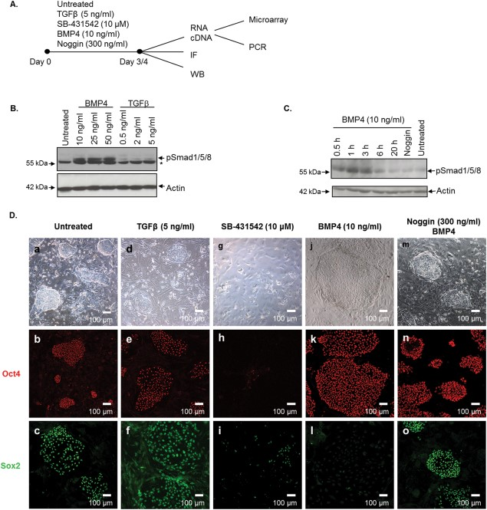
In addition to its role in lineage specification, BMP4 also influences cell morphology (Figure 6) by modulating the expression of genes involved in cytoskeletal structure, adhesion, and migration [48]. Cells treated with BMP4 adopted a more flattened and loosely dispersed colony morphology (Figure 16), potentially improving signal accessibility and reducing spontaneous aggregation into compact clusters. Such organization may suppress off-target lineage differentiation and contribute to more homogeneous cardiomyocyte output [92]. Consistently, cells under BMP4/LDN-193189 treatment maintained robust differentiation across a confluency range of 50–80% without loss of CHIR99021 responsiveness (data not shown). This flexibility simplifies experimental handling and may help preserve cardiac lineage commitment, although further validation across different WNT timing conditions is still needed.
Figure 16
BMP4 promotes colony flattening and pluripotency exit, establishing a morphological basis for synchronized differentiation.
Cells were fixed and stained with primary antibodies: mouse anti-OCT4 and rabbit anti-SOX2. Secondary antibodies used were anti-mouse Cy3 (red) and anti-rabbit AlexaFluor488 (green), respectively. The images illustrate the effects of BMP4 treatment on hESC morphology and marker expression. Adapted from Richter et al. (2014), Stem Cells, 32(3), 636–648. https://doi.org/10.1002/stem.1592.

Inconsistency of MYL2 expression under mid-stage RA treatment
RA exposure between Day 5–10 produced inconsistent transcriptional outcomes with regard to ventricular marker MYL2. MYL2 expression showed a slight increase in one dataset (Figure 13B), yet was markedly reduced in another (Figure 14A), alongside broader downregulation of maturation-associated genes.

This discrepancy suggests that RA-mediated chamber-specific differentiation during this intermediate window is particularly sensitive to subtle changes in detection timing, cellular heterogeneity, or RA responsiveness. Importantly, the lack of reproducible MYL2 elevation—despite using a dosage (0.1 μM) previously associated with ventricular specification—may reflect a temporal uncoupling between subtype induction and structural maturation. Such inconsistency could explain the low reproducibility of RA-based chamber specification protocols reported in previous studies and highlights the need for additional cues or optimized timing to ensure stable fate acquisition [5].

Moreover, reliance on qPCR alone may be insufficient to resolve subtle differences between cardiomyocyte subtypes. Electrophysiological analyses, such as patch-clamp recordings, offer functional validation by distinguishing atrial, ventricular, and nodal cells based on action potential and ion channel properties, providing a more comprehensive assessment of subtype identity [5, 93, 94].

Combined RA and BMP4/LDN-193189 treatment enhance consistency but needs further refinement
Subsequent treatment with different concentrations of RA exhibits a clear dose- and time-dependent effect on cardiomyocyte subtype specification, with 0.5 μM favoring atrial specification (Figure 11D). RA exposure between Day 10–15 enhances MYL2 expression and suggests ventricular-like transcriptional identity, yet this is not always accompanied by full maturation (Figure 13B & Figure 14). This uncoupling suggests that additional cues—such as thyroid hormone, mechanical stimuli, or metabolic factors—may be required to complete terminal differentiation. Consistent with in vivo findings, vitamin A–deficient and RXRα-deficient embryos also show flattened, loosely connected subepicardial myocytes, highlighting the importance of timely RA input in ventricular identity maintenance [53].

A single RA dose may not be sufficient to consistently induce chamber-specific cardiomyocyte differentiation, as gene expression levels of subtype markers did not show clear divergence across repeated experiments (data not shown). Therefore, this study favors a sustained RA treatment strategy during the differentiation window to better simulate the gradual RA accumulation observed in the posterior SHF in vivo [59-61].

The combination of RA with BMP4/LDN-193189 improves morphological uniformity and differentiation reproducibility but still requires tuning to enhance subtype resolution. Future efforts should focus on optimizing dosage schedules and integrating higher-resolution readouts to reliably direct cardiomyocyte subtype fate.

Acknowledgement
I would like to express my sincere gratitude to my supervisor for their patient guidance and invaluable advice throughout the course of this project. I am also deeply thankful to all the members of the laboratory, especially the senior student who mentored me during the experiment and data analysis process. Their support and encouragement made this research possible. Finally, I am grateful to the University for providing a nurturing academic environment, and to my family and friends whose unwavering support has been essential to my learning journey.

Name | Sequence (F) | Sequence (R)
GAPDH | GTGGACCTGACCTGCCGTCT | GGAGGAGTGGGTGTCGCTGT
TBP | CTGCGGTACAATCCCAGAACT | CCCGAAACGCCGAATATAATCC
HAND1 | GTGCGTCCTTTAATCCTCTTC | GTGAGAGCAAGCGGAAAAG
SHOX2 | CCTACATGATGTTCCCAGCA | GGAGTTCTTGCTGGTGGTCT
TBX5 | CTGTGGCTAAAATTCCACGAAGT | GTGATCGTCGGCAGGTACAAT
HCN4 | GACTGCTGGGTGTCCATCAA | AGAGCG CGTAGGAGTACTGCTT
IRX4 | TTGGACTCCTGGGAACATGGACAA | ATGCTTCAGGGTATCTGGCCTCTT
MYH7 | TCGTGCCTGATGACAAACAGGAGT | ATACTCGGTCTCGGCAGTGACTTT
MYL2 | TGTCCCTACCTTGTCTGTTAGCCA | ATTGGAACATGGCCTCTGGATGGA
MYH6 | GCCCTTTGACATTCGCACTG | GGTTTCAGCAATGACCTTGCC
NR2F2 | TGATGTAGCCCATGTGGAAAG | GCTGCCGGACAGTAACATATC
MYL7 | ACATCATCACCCATGGAGACGAGA | GCAACAGAGTTTATTGAGGTGCCC
TNNT2 | ACATCATCACCCATGGAGACGAGA | GCAACAGAGTTTATTGAGGTGCCC
ISL1 | GCGGAGTGTAATCAGTATTTGGA | GCATTTGATCCCGTACAACCT
KCNJ2 | GTGCGAACCAACCGCTACA | CCAGCGAATGTCCACACAC
CACNA1C | TGATTCCAACGCCACCAATTC | GAGGAGTCCATAGGCGATTACT
GJA1 | TCTCTCATGTGCGCTTCTGG | TGACACCATCAGTTTGGGCA
TBX18 | TTAACCTTGTCCGTCTGCCTGAGT | GTAATGGGCTTTGGCCTTTGCACT
SCN5A | TCTCTATGGCAATCCACCCCA | GAGGACATACAAGGCGTTGGT
RYR2 | ACAACAGAAGCTATGCTTGGC | GAGGAGTGTTCGATGACCACC
SERCA2 | ATGGGGCTCCAACGAGTTAC | TTTCCTGCCATACACCCACAA
CPTB | CCTGCTACATGGCAACTGCTA | AGAGGTGCCCAATGATGGGA
Table S1
Primer list of used in this expreiment

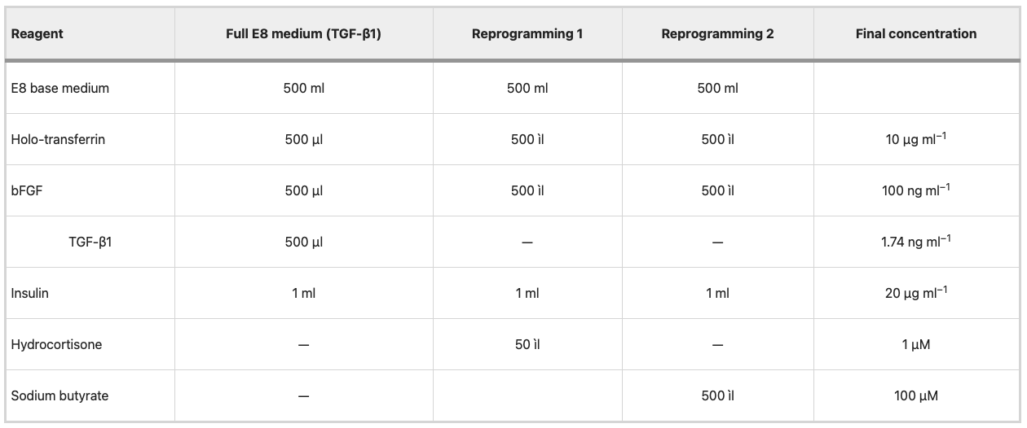
Table S2
E8-related media compositions for hPSC reprogramming and maintenance.
The E8 medium used in this study comprises DMEM/F12 (Gibco), Vc/Selenium, holo-transferrin, 10 ng/mL insulin, 1.74 ng/mL TGF-β1, and 100 ng/mL FGF2. Adapted from Beers et al. (2012), Nature Protocols, 7(11), 2029–2040. https://doi.org/10.1038/nprot.2012.130

Reference
1. Zhao, M.-T., N.-Y. Shao, and V. Garg, Subtype-specific cardiomyocytes for precision medicine: Where are we now? Stem Cells, 2020. 38(7): p. 822-833.
2. Paige, S.L., et al., Molecular regulation of cardiomyocyte differentiation. Circulation research, 2015. 116(2): p. 341-353.
3. Mummery, C., et al., Differentiation of human embryonic stem cells to cardiomyocytes: role of coculture with visceral endoderm-like cells. Circulation, 2003. 107(21): p. 2733-2740.
4. Burridge, Paul W., et al., Production of De Novo Cardiomyocytes: Human Pluripotent Stem Cell Differentiation and Direct Reprogramming. Cell Stem Cell, 2012. 10(1): p. 16-28.
5. Wiesinger, A., et al., Retinoic acid signaling in heart development: Application in the differentiation of cardiovascular lineages from human pluripotent stem cells. Stem Cell Reports, 2021. 16(11): p. 2589-2606.
6. Yang, D., et al., Modeling human multi-lineage heart field development with pluripotent stem cells. Cell Stem Cell, 2022. 29(9): p. 1382-1401. e8.
7. Galdos, F.X., et al., Combined lineage tracing and scRNA-seq reveals unexpected first heart field predominance of human iPSC differentiation. Elife, 2023. 12: p. e80075.
8. Karakikes, I., et al., Small molecule-mediated directed differentiation of human embryonic stem cells toward ventricular cardiomyocytes. 2014, Oxford University Press. p. 18-31.
9. Willems, E., et al., Small-molecule inhibitors of the Wnt pathway potently promote cardiomyocytes from human embryonic stem cell–derived mesoderm. Circulation research, 2011. 109(4): p. 360-364.
10. Lindsley, R.C., et al., Canonical Wnt signaling is required for development of embryonic stem cell-derived mesoderm. 2006.
11. Tirosh-Finkel, L., et al., BMP-mediated inhibition of FGF signaling promotes cardiomyocyte differentiation of anterior heart field progenitors. Development, 2010. 137(18): p. 2989-3000.
12. Ueno, S., et al., Biphasic role for Wnt/β-catenin signaling in cardiac specification in zebrafish and embryonic stem cells. Proceedings of the National Academy of Sciences, 2007. 104(23): p. 9685-9690.
13. Brade, T., et al., Embryonic heart progenitors and cardiogenesis. Cold Spring Harbor perspectives in medicine, 2013. 3(10): p. a013847.
14. Christoffels, V.M., et al., Chamber Formation and Morphogenesis in the Developing Mammalian Heart. Developmental Biology, 2000. 223(2): p. 266-278.
15. Martinsen, B.J., Reference guide to the stages of chick heart embryology. Developmental dynamics: an official publication of the American Association of Anatomists, 2005. 233(4): p. 1217-1237.
16. Später, D., et al., A HCN4+ cardiomyogenic progenitor derived from the first heart field and human pluripotent stem cells. Nature cell biology, 2013. 15(9): p. 1098-1106.
17. Abu-Issa, R. and M.L. Kirby, Heart field: from mesoderm to heart tube. Annu. Rev. Cell Dev. Biol., 2007. 23(1): p. 45-68.
18. Kelly, R.G., M.E. Buckingham, and A.F. Moorman, Heart fields and cardiac morphogenesis. Cold Spring Harbor perspectives in medicine, 2014. 4(10): p. a015750.
19. Zaffran, S., et al., Right ventricular myocardium derives from the anterior heart field. Circulation research, 2004. 95(3): p. 261-268.
20. Buckingham, M., S. Meilhac, and S. Zaffran, Building the mammalian heart from two sources of myocardial cells. Nature Reviews Genetics, 2005. 6(11): p. 826-835.
21. Xu, Y., Y. Shi, and S. Ding, A chemical approach to stem-cell biology and regenerative medicine. Nature, 2008. 453(7193): p. 338-344.
22. Rajala, K., M. Pekkanen-Mattila, and K. Aalto-Setälä, Cardiac differentiation of pluripotent stem cells. Stem cells international, 2011. 2011(1): p. 383709.
23. Kattman, S.J., et al., Stage-specific optimization of activin/nodal and BMP signaling promotes cardiac differentiation of mouse and human pluripotent stem cell lines. Cell stem cell, 2011. 8(2): p. 228-240.
24. Yang, L., et al., Human cardiovascular progenitor cells develop from a KDR+ embryonic-stem-cell-derived population. Nature, 2008. 453(7194): p. 524-528.
25. Laflamme, M.A., et al., Cardiomyocytes derived from human embryonic stem cells in pro-survival factors enhance function of infarcted rat hearts. Nature biotechnology, 2007. 25(9): p. 1015-1024.
26. Isomi, M., et al., Overexpression of Gata4, Mef2c, and Tbx5 Generates Induced Cardiomyocytes Via Direct Reprogramming and Rare Fusion in the Heart. Circulation, 2021. 143(21): p. 2123-2125.
27. Mummery, C., et al., Differentiation of Human Embryonic Stem Cells to Cardiomyocytes. Circulation, 2003. 107(21): p. 2733-2740.
28. Liang, W., et al., Canonical Wnt signaling promotes pacemaker cell specification of cardiac mesodermal cells derived from mouse and human embryonic stem cells. Stem Cells, 2020. 38(3): p. 352-368.
29. Laco, F., et al., Unraveling the Inconsistencies of Cardiac Differentiation Efficiency Induced by the GSK3b; Inhibitor CHIR99021 in Human Pluripotent Stem Cells. Stem Cell Reports, 2018. 10(6): p. 1851-1866.
30. Kim, M.-S., et al., Activin-A and Bmp4 levels modulate cell type specification during CHIR-induced cardiomyogenesis. PloS one, 2015. 10(2): p. e0118670.
31. Mine, N., R.M. Anderson, and J. Klingensmith, BMP antagonism is required in both the node and lateral plate mesoderm for mammalian left-right axis establishment. Development, 2008. 135(14): p. 2425-2434.
32. Jones, C.M., K.M. Lyons, and B.L.M. Hogan, Involvement of Bone Morphogenetic Protein-4 (BMP-4) and Vgr-1 in morphogenesis and neurogenesis in the mouse. Development, 1991. 111(2): p. 531-542.
33. Schultheiss, T.M., J. Burch, and A.B. Lassar, A role for bone morphogenetic proteins in the induction of cardiac myogenesis. Genes & development, 1997. 11(4): p. 451-462.
34. Prall, O.W.J., et al., An Nkx2-5/Bmp2/Smad1 Negative Feedback Loop Controls Heart Progenitor Specification and Proliferation. Cell, 2007. 128(5): p. 947-959.
35. Tirosh-Finkel, L., et al., Mesoderm progenitor cells of common origin contribute to the head musculature and the cardiac outflow tract. 2006.
36. Wang, J., et al., Bmp signaling regulates myocardial differentiation from cardiac progenitors through a MicroRNA-mediated mechanism. Developmental cell, 2010. 19(6): p. 903-912.
37. Jing, Y., et al., A BMP4-p38 MAPK signaling axis controls ISL1 protein stability and activity during cardiogenesis. Stem Cell Reports, 2021. 16(8): p. 1894-1905.
38. Cagavi, E., et al., Functional cardiomyocytes derived from Isl1 cardiac progenitors via Bmp4 stimulation. PloS one, 2014. 9(12): p. e110752.
39. Reshef, R., M. Maroto, and A.B. Lassar, Regulation of dorsal somitic cell fates: BMPs and Noggin control the timing and pattern of myogenic regulator expression. Genes & development, 1998. 12(3): p. 290-303.
40. Pourquié, O., et al., Lateral and axial signals involved in avian somite patterning: a role for BMP4. Cell, 1996. 84(3): p. 461-471.
41. Ao, A., et al., DMH1, a novel BMP small molecule inhibitor, increases cardiomyocyte progenitors and promotes cardiac differentiation in mouse embryonic stem cells. 2012.
42. Sanvitale, C.E., et al., A new class of small molecule inhibitor of BMP signaling. PloS one, 2013. 8(4): p. e62721.
43. Cuny, G.D., et al., Structure–activity relationship study of bone morphogenetic protein (BMP) signaling inhibitors. Bioorganic & medicinal chemistry letters, 2008. 18(15): p. 4388-4392.
44. Hao, J., et al., Dorsomorphin, a selective small molecule inhibitor of BMP signaling, promotes cardiomyogenesis in embryonic stem cells. PloS one, 2008. 3(8): p. e2904.
45. Tzahor, E. and S.M. Evans, Pharyngeal mesoderm development during embryogenesis: implications for both heart and head myogenesis. Cardiovascular research, 2011. 91(2): p. 196-202.
46. Loh, K.M., et al., Mapping the pairwise choices leading from pluripotency to human bone, heart, and other mesoderm cell types. Cell, 2016. 166(2): p. 451-467.
47. Bernardo, A.S., et al., BRACHYURY and CDX2 mediate BMP-induced differentiation of human and mouse pluripotent stem cells into embryonic and extraembryonic lineages. Cell stem cell, 2011. 9(2): p. 144-155.
48. Richter, A., et al., BMP4 Promotes EMT and Mesodermal Commitment in Human Embryonic Stem Cells via SLUG and MSX2. Stem Cells, 2014. 32(3): p. 636-648.
49. Chen, J.-N., et al., Left-right pattern of cardiac BMP4 may drive asymmetry of the heart in zebrafish. Development, 1997. 124(21): p. 4373-4382.
50. Cai, C.-L., et al., Isl1 identifies a cardiac progenitor population that proliferates prior to differentiation and contributes a majority of cells to the heart. Developmental cell, 2003. 5(6): p. 877-889.
51. Sucov, H.M., et al., RXR alpha mutant mice establish a genetic basis for vitamin A signaling in heart morphogenesis. Genes & development, 1994. 8(9): p. 1007-1018.
52. Niederreither, K., et al., Embryonic retinoic acid synthesis is essential for heart morphogenesis in the mouse. Development, 2001. 128(7): p. 1019-1031.
53. Kastner, P., et al., Vitamin A deficiency and mutations of RXRα, RXRβ and RARα lead to early differentiation of embryonic ventricular cardiomyocytes. Development, 1997. 124(23): p. 4749-4758.
54. Brade, T., et al., Retinoic acid stimulates myocardial expansion by induction of hepatic erythropoietin which activates epicardial Igf2. Development, 2011. 138(1): p. 139-148.
55. Niederreither, K. and P. Dollé, Retinoic acid in development: towards an integrated view. Nature Reviews Genetics, 2008. 9(7): p. 541-553.
56. Niederreither, K., et al., Embryonic retinoic acid synthesis is essential for early mouse post-implantation development. Nature genetics, 1999. 21(4): p. 444-448.
57. Yuan, S., et al., Intraciliary calcium oscillations initiate vertebrate left-right asymmetry. Current biology, 2015. 25(5): p. 556-567.
58. Nonaka, S., et al., Randomization of left–right asymmetry due to loss of nodal cilia generating leftward flow of extraembryonic fluid in mice lacking KIF3B motor protein. Cell, 1998. 95(6): p. 829-837.
59. Vermot, J., et al., Retinoic acid controls the bilateral symmetry of somite formation in the mouse embryo. Science, 2005. 308(5721): p. 563-566.
60. Ryckebusch, L., et al., Retinoic acid deficiency alters second heart field formation. Proceedings of the National Academy of Sciences, 2008. 105(8): p. 2913-2918.
61. Vilhais-Neto, G.C., et al., Rere controls retinoic acid signalling and somite bilateral symmetry. Nature, 2010. 463(7283): p. 953-957.
62. Roberts, C., et al., Cyp26 genes a1, b1 and c1 are down-regulated in Tbx1 null mice and inhibition of Cyp26 enzyme function produces a phenocopy of DiGeorge Syndrome in the chick. Human molecular genetics, 2006. 15(23): p. 3394-3410.
63. Lemme, M., et al., Atrial-like engineered heart tissue: an in vitro model of the human atrium. Stem cell reports, 2018. 11(6): p. 1378-1390.
64. Wiesinger, A., et al., Retinoic acid signaling in heart development: Application in the differentiation of cardiovascular lineages from human pluripotent stem cells. Stem Cell Reports, 2021. 16(11): p. 2589-2606.
65. Cyganek, L., et al., Deep phenotyping of human induced pluripotent stem cell–derived atrial and ventricular cardiomyocytes. JCI insight, 2018. 3(12): p. e99941.
66. Hofbauer, P., et al., Cardioids reveal self-organizing principles of human cardiogenesis. Cell, 2021. 184(12): p. 3299-3317. e22.
67. Guadix, J.A., et al., Human pluripotent stem cell differentiation into functional epicardial progenitor cells. Stem Cell Reports, 2017. 9(6): p. 1754-1764.
68. Tan, J.J., et al., Human iPS-derived pre-epicardial cells direct cardiomyocyte aggregation expansion and organization in vitro. Nature communications, 2021. 12(1): p. 4997.
69. Devalla, H.D., et al., Atrial‐like cardiomyocytes from human pluripotent stem cells are a robust preclinical model for assessing atrial‐selective pharmacology. EMBO molecular medicine, 2015. 7(4): p. 394-410.
70. Ivanovitch, K., et al., Ventricular, atrial, and outflow tract heart progenitors arise from spatially and molecularly distinct regions of the primitive streak. PLoS biology, 2021. 19(5): p. e3001200.
71. Lescroart, F., et al., Defining the earliest step of cardiovascular lineage segregation by single-cell RNA-seq. Science, 2018. 359(6380): p. 1177-1181.
72. Lee, J.H., et al., Human pluripotent stem cell-derived atrial and ventricular cardiomyocytes develop from distinct mesoderm populations. Cell stem cell, 2017. 21(2): p. 179-194. e4.
73. Duggal, G., et al., Alternative routes to induce naive pluripotency in human embryonic stem cells. Stem cells, 2015. 33(9): p. 2686-2698.
74. Zhang, F.-B., et al., Passage-restricted differentiation potential of mesenchymal stem cells into cardiomyocyte-like cells. Biochemical and Biophysical Research Communications, 2005. 336(3): p. 784-792.
75. Amit, M., et al., Clonally derived human embryonic stem cell lines maintain pluripotency and proliferative potential for prolonged periods of culture. Developmental biology, 2000. 227(2): p. 271-278.
76. Diamante, L. and G. Martello, Metabolic regulation in pluripotent stem cells. Current Opinion in Genetics & Development, 2022. 75: p. 101923.
77. Radisic, M., et al., Oxygen gradients correlate with cell density and cell viability in engineered cardiac tissue. Biotechnology and bioengineering, 2006. 93(2): p. 332-343.
78. Lee, M.Y., et al., High density cultures of embryoid bodies enhanced cardiac differentiation of murine embryonic stem cells. Biochemical and biophysical research communications, 2011. 416(1-2): p. 51-57.
79. Le, M.N.T., et al., Cardiac differentiation at an initial low density of human-induced pluripotent stem cells. In Vitro Cellular & Developmental Biology-Animal, 2018. 54: p. 513-522.
80. Bruneau, B.G., et al., Chamber-specific cardiac expression of Tbx5 and heart defects in Holt–Oram syndrome. Developmental biology, 1999. 211(1): p. 100-108.
81. Takeuchi, J.K. and B.G. Bruneau, Directed transdifferentiation of mouse mesoderm to heart tissue by defined factors. Nature, 2009. 459(7247): p. 708-711.
82. Biben, C. and R.P. Harvey, Homeodomain factor Nkx2-5 controls left/right asymmetric expression of bHLH gene eHand during murine heart development. Genes & development, 1997. 11(11): p. 1357-1369.
83. Lien, C.-L., et al., Control of early cardiac-specific transcription of Nkx2-5 by a GATA-dependent enhancer. Development, 1999. 126(1): p. 75-84.
84. Bu, L., et al., Human ISL1 heart progenitors generate diverse multipotent cardiovascular cell lineages. Nature, 2009. 460(7251): p. 113-117.
85. de Soysa, T.Y., et al., Single-cell analysis of cardiogenesis reveals basis for organ-level developmental defects. Nature, 2019. 572(7767): p. 120-124.
86. Kang, J., et al., Isl1 is a direct transcriptional target of Forkhead transcription factors in second heart field-derived mesoderm. Developmental biology, 2009. 334(2): p. 513-522.
87. England, J. and S. Loughna, Heavy and light roles: myosin in the morphogenesis of the heart. Cellular and Molecular Life Sciences, 2013. 70: p. 1221-1239.
88. Li, G., et al., Transcriptomic profiling maps anatomically patterned subpopulations among single embryonic cardiac cells. Developmental cell, 2016. 39(4): p. 491-507.
89. Beers, J., et al., Passaging and colony expansion of human pluripotent stem cells by enzyme-free dissociation in chemically defined culture conditions. Nature protocols, 2012. 7(11): p. 2029-2040.
90. Brand, T., Heart development: molecular insights into cardiac specification and early morphogenesis. Developmental biology, 2003. 258(1): p. 1-19.
91. Xu, R.-H., et al., BMP4 initiates human embryonic stem cell differentiation to trophoblast. Nature biotechnology, 2002. 20(12): p. 1261-1264.
92. Osafune, K., et al., Marked differences in differentiation propensity among human embryonic stem cell lines. Nature biotechnology, 2008. 26(3): p. 313-315.
93. Zhang, Q., et al., Direct differentiation of atrial and ventricular myocytes from human embryonic stem cells by alternating retinoid signals. Cell research, 2011. 21(4): p. 579-587.
94. Yi, T., et al., Electrophysiological mapping of embryonic mouse hearts: mechanisms for developmental pacemaker switch and internodal conduction pathway. Journal of cardiovascular electrophysiology, 2012. 23(3): p. 309-318.

